**Supplementary Materials for**

**Multi Contact-based Folding Method for *de novo* Protein Structure Prediction**

Minghua Hou, Chunxiang Peng, Xiaogen Zhou, Biao Zhang and Guijun Zhang∗

∗To whom correspondence should be addressed;

E-mail: zgj@zjut.edu.cn (Guijun Zhang);

**S1. Details of MultiCFold.**

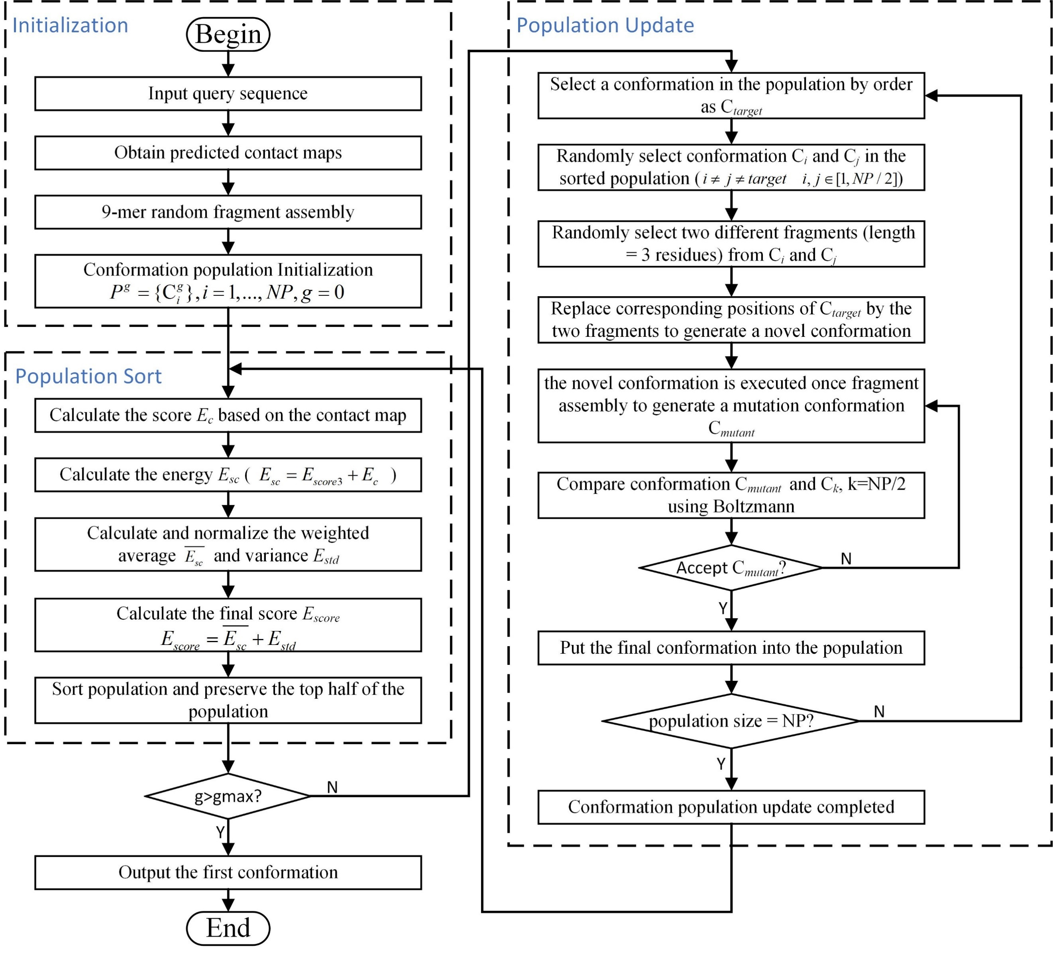

**Figure S1**. Framework of MultiCFold.

The framework of MultiCFold is described as Figure S1. The sequence and several contact maps are used as input, and MultiCFold finally outputs the predicted three-dimensional structure of the target sequence. MultiCFold is developed on the framework of evolutionary algorithm. First, the initial population  is generated through random fragment assembly using 9-mer fragment. After initialization, the weighted average and variance of each decoy will be obtained based on a scoring model based on multiple contact maps. And then, and of each decoy will be normalized according to that of all decoys in the population, namely, and . Finally, the decoys in population will be sorted by , where 0.25.

In the population update, the top half of the population will be preserved and the rest will be wiped out. Based on the selected decoys, fragment recombination and assembly are performed to generate new decoys for further populating the population.

In fragment recombination, each preserved decoy in the sorted population will be selected in turn as the target conformation, . Two mutually different decoys are randomly selected, namely, and , where . Afterward, two mutually different fragments (length = 3 residues) are randomly selected from and , and then the corresponding positions of are replaced by the two fragments to generate a novel conformation. Finally, the novel conformation is executed once fragment assembly to generate a mutation conformation .

In fragment assembly, select different fragment libraries based on the number of the current iteration. When the number of the current iteration is less than 1/5 of the maximum number of iterations , one fragment in the 9-mer fragment library is randomly selected to replace the corresponding position; otherwise, the 3-mer fragment library is selected to perform the operation.

The mutation conformation is compared with target conformation and received through Metropolis Monte Carlo. After filling up the population, it will enter the next iteration until the number of iterations is greater than the maximum number set. Finally, the lowest-energy conformation is selected from the final population as the prediction model.

**S2. Parameter setting.**

The effect of **wighting parameters** on the equations are analyzed and discussed, respectively. The parameters are listed in Table S1.

**Table S1.** Parameter descriptions in MultiCFold.

| Parameter | value | descriptions |
| --- | --- | --- |
| *ω*1 | 0.213 | Weight of contact map 1 in equation 5 |
| *ω*2 | 0.233 | Weight of contact map 2 in equation 5 |
| *ω*3 | 0.189 | Weight of contact map 3 in equation 5 |
| *ω*4 | 0.188 | Weight of contact map 4 in equation 5 |
| *λ*1 | 0.75 | Weight of average in equation 8 |
| *λ*2 | 0.25 | Weight of variance in equation 8 |

Parameter explanations:

*ω*1 – the weight of contact map 1, which is predicted by TripletRes. The value of *ω*1 is 0.213, which is equal to the F-score for the contact predictor performance in CASP13.

*ω*2 – the weight of contact map 2, which is predicted by RaptorX-Contact. The value of *ω*2 is 0.233, which is equal to the F-score for the contact predictor performance in CASP13.

*ω*3 – the weight of contact map 3, which is predicted by DeepMetaPSICOV. The value of *ω*3 is 0.189, which is equal to the F-score for the contact predictor performance in CASP13.

*ω*4 – the weight of contact map 4, which is predicted by SPOT-Contact. The value of *ω*4 is 0.188, which is equal to the F-score for the contact predictor performance in CASP13.

*λ*1, *λ*2– the weight of average and variance in equation 8, which is set to increases the differences between two energy terms.

1. The weight values for the four contact predictors (TripletRes, RaptorX-Contact, DeepMetaPSICOV, SPOT-Contact).

In this work, the F-score of the four servers in CASP13 are used as the weight *ω*1, *ω*2, *ω*3 and *ω*4 of contact maps. Prediction performance was measured with F-score and precision in assessing the accuracy of contact predictions in CASP13. The F-score is defined as the harmonic mean of precision and recall:

 (S1)

where precision and recall are calculated as: ;from the observed true positive (*TP*), false positive (*FP*), and false negative cases (*FN*).

The group number, name and F-score of these four contact predictors in CASP13 show in Table S2 and Averages of Precision and F-score over submitted predictions in CASP13 show in Figure S2.

**Table S2.** F-score for four contact predictors performance in CASP13.

|  |  |  |  |
| --- | --- | --- | --- |
| Contact Predictors | Gr.# in CASP13 | Gr.Name in CASP13 | F-score |
| TripletRes | 032 | TripletRes | 0.213 |
| RaptorX-Contact | 498 | RaptorX-Contact | 0.233 |
| DeepMetaPSICOV | 491 | DMP | 0.189 |
| SPOT-Contact | 189 | ZHOU-Contact | 0.188 |

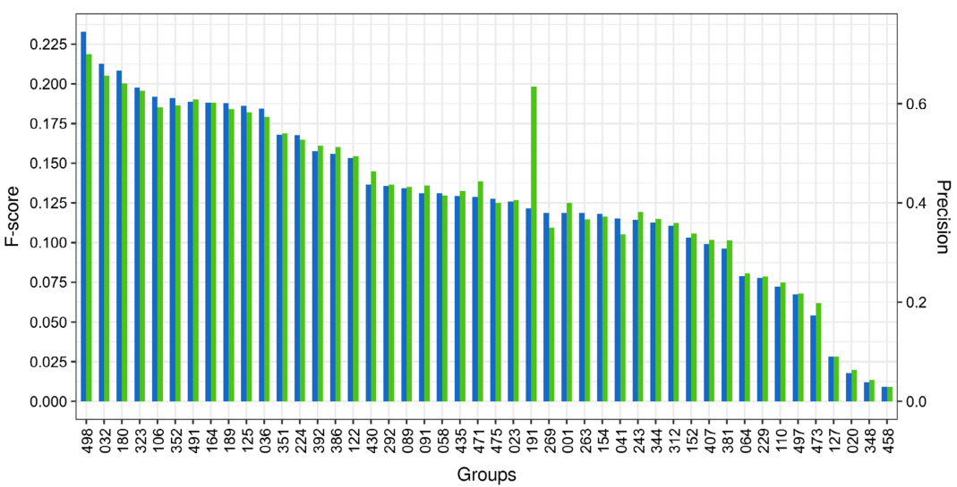

**Figure S2**. Averages of Precision and F-score over submitted predictions in CASP13.

1. The weight values of lambda in equation 8.

In equation 8, the lambda and , more emphasis to the average value in assessing conformation. As illustrated in Figure S3 (a), we hope to choose a conformation with a better score instead of having the similar score on all four contact-map-based models. The variance is expected to play the role of choice in the case of the average little difference, as illustrated in Figure S3 (b).

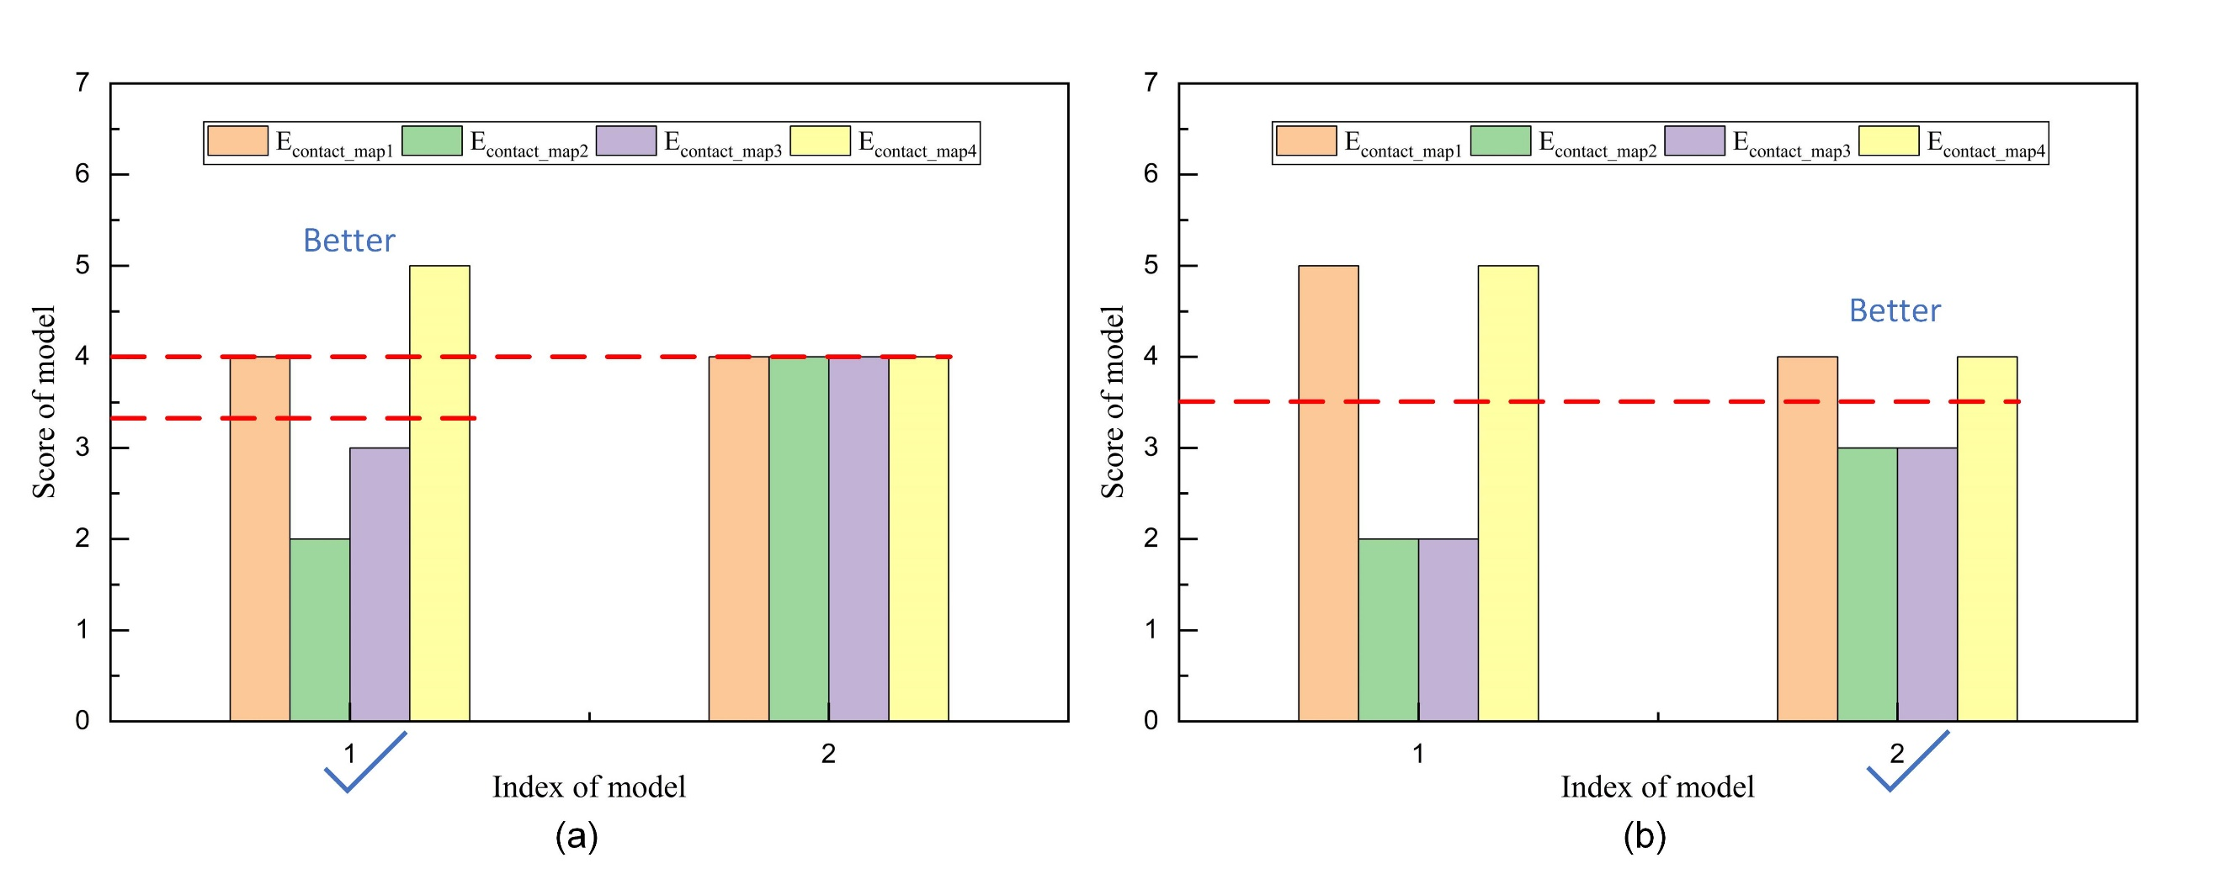

**Figure S3**. Two different situations of conformation selection. (a). The better model (model 1) has a lower average but a higher variance. (b). The better model (model 2) has a same average but a lower variance.

In order to show the effect of the weight values of lambda ( and ). Table S3 shows that 20 of the 200 conformations in the population at one of the 500 iterations in the process of predicting protein 2CMX_A by MultiCFold. As shown in Table S3, we highlighted two groups, group A and B, with three proteins each.

From group A, the better conformation has a lower average score (Ave_Esc and ) but a higher variance score (Estd and ). Especially from the normalized scores, the and have opposite trends but the magnitude of the changes are similar. In this case, setting the weights and to increase the difference between the and , which will be helpful to choose a conformation with a better score instead of having the similar score on all four contact-map-based models, as illustrated in Figure S3 (a).

From group B, the better conformation has a lower variance score (Estd and ) but a slightly higher average score (Ave_Esc and ). Especially from the normalized scores, the of conformations in group B are similar but there is a clear change in the . In this case, although is smaller than , it is enough to choose the better conformation. And that's what we would expect, when the average score of conformations is similar, we want to pick out the conformation that fits better with all four of the contact maps, as illustrated in Figure S3 (b).

In addition, as shown in Table S4, the prediction results of MultiCFold and Rosetta for 90 benchmark proteins also shows such a design can effectively play the role of contacts. From the above experiments, the setting of parameters and can achieve our expected effect.

**Table S3.** Energy of 20 of the 200 conformations in the population at one of the 500 iterations for protein 2CMX_A.

| Group | NO. | Ave_Esc | Estd |  |  | Escore | RMSD |
| --- | --- | --- | --- | --- | --- | --- | --- |
|  | 1 | 107.1 | 66.6 | 0.000 | 0.037 | 0.009 | 5.15 |
| 2 | 268.8 | 36.3 | 0.075 | 0.000 | 0.056 | 6.14 |
| 3 | 482.2 | 182.3 | 0.174 | 0.178 | 0.175 | 6.47 |
| 4 | 531.0 | 241.5 | 0.197 | 0.251 | 0.210 | 7.46 |
| 5 | 526.0 | 250.7 | 0.194 | 0.262 | 0.211 | 7.57 |
| 6 | 535.6 | 254.4 | 0.199 | 0.266 | 0.215 | 8.78 |
| **B** | **7** | **563.5** | **223.8** | **0.212** | **0.229** | **0.216** | **9.02** |
| **8** | **543.6** | **253.2** | **0.202** | **0.265** | **0.218** | **9.66** |
| **9** | **533.9** | **277.2** | **0.198** | **0.294** | **0.222** | **9.89** |
|  | 10 | 659.3 | 300.2 | 0.256 | 0.322 | 0.273 | 10.01 |
| 11 | 659.0 | 307.2 | 0.256 | 0.331 | 0.275 | 11.35 |
| 12 | 721.4 | 257.7 | 0.285 | 0.270 | 0.281 | 11.55 |
| 13 | 751.9 | 293.5 | 0.299 | 0.314 | 0.303 | 12.41 |
| 14 | 854.1 | 256.1 | 0.347 | 0.268 | 0.327 | 12.63 |
| 15 | 858.4 | 292.6 | 0.349 | 0.313 | 0.340 | 14.88 |
| **A** | **16** | **1188.4** | **468.8** | **0.502** | **0.528** | **0.508** | **15.19** |
| **17** | **1294.0** | **447.9** | **0.551** | **0.503** | **0.539** | **16.35** |
| **18** | **1442.9** | **419.4** | **0.620** | **0.468** | **0.582** | **17.49** |
|  | 19 | 1491.8 | 499.1 | 0.642 | 0.565 | 0.623 | 18.10 |
| 20 | 2155.8 | 819.0 | 0.950 | 0.956 | 0.952 | 21.99 |

**Table S4.** Prediction results of MultiCFold and Rosetta for 90 benchmark proteins.

|  |  |  |  |  |  |  |
| --- | --- | --- | --- | --- | --- | --- |
| Method | RMSD | TM-score | #TM≥0.5 | #TM≥0.7 | #TM≥0.8 | P-value |
| MultiCFold | 5.824 | 0.622 | 83 | 21 | 3 | NA |
| Rosetta | 11.488 | 0.368 | 16 | 1 | 0 | 5.32e-38 |
| #TM≥0.5, ≥0.7, ≥0.8 are the number of the predicted model with TM-score≥0.5, ≥0.7, ≥0.8, respectively. | | | | | | |
| P-value is the results of the Wilcoxon signed rank test. | | | | | | |
| NA represents that there has no data. | | | | | | |

**S3. Details of MetaCFold.**

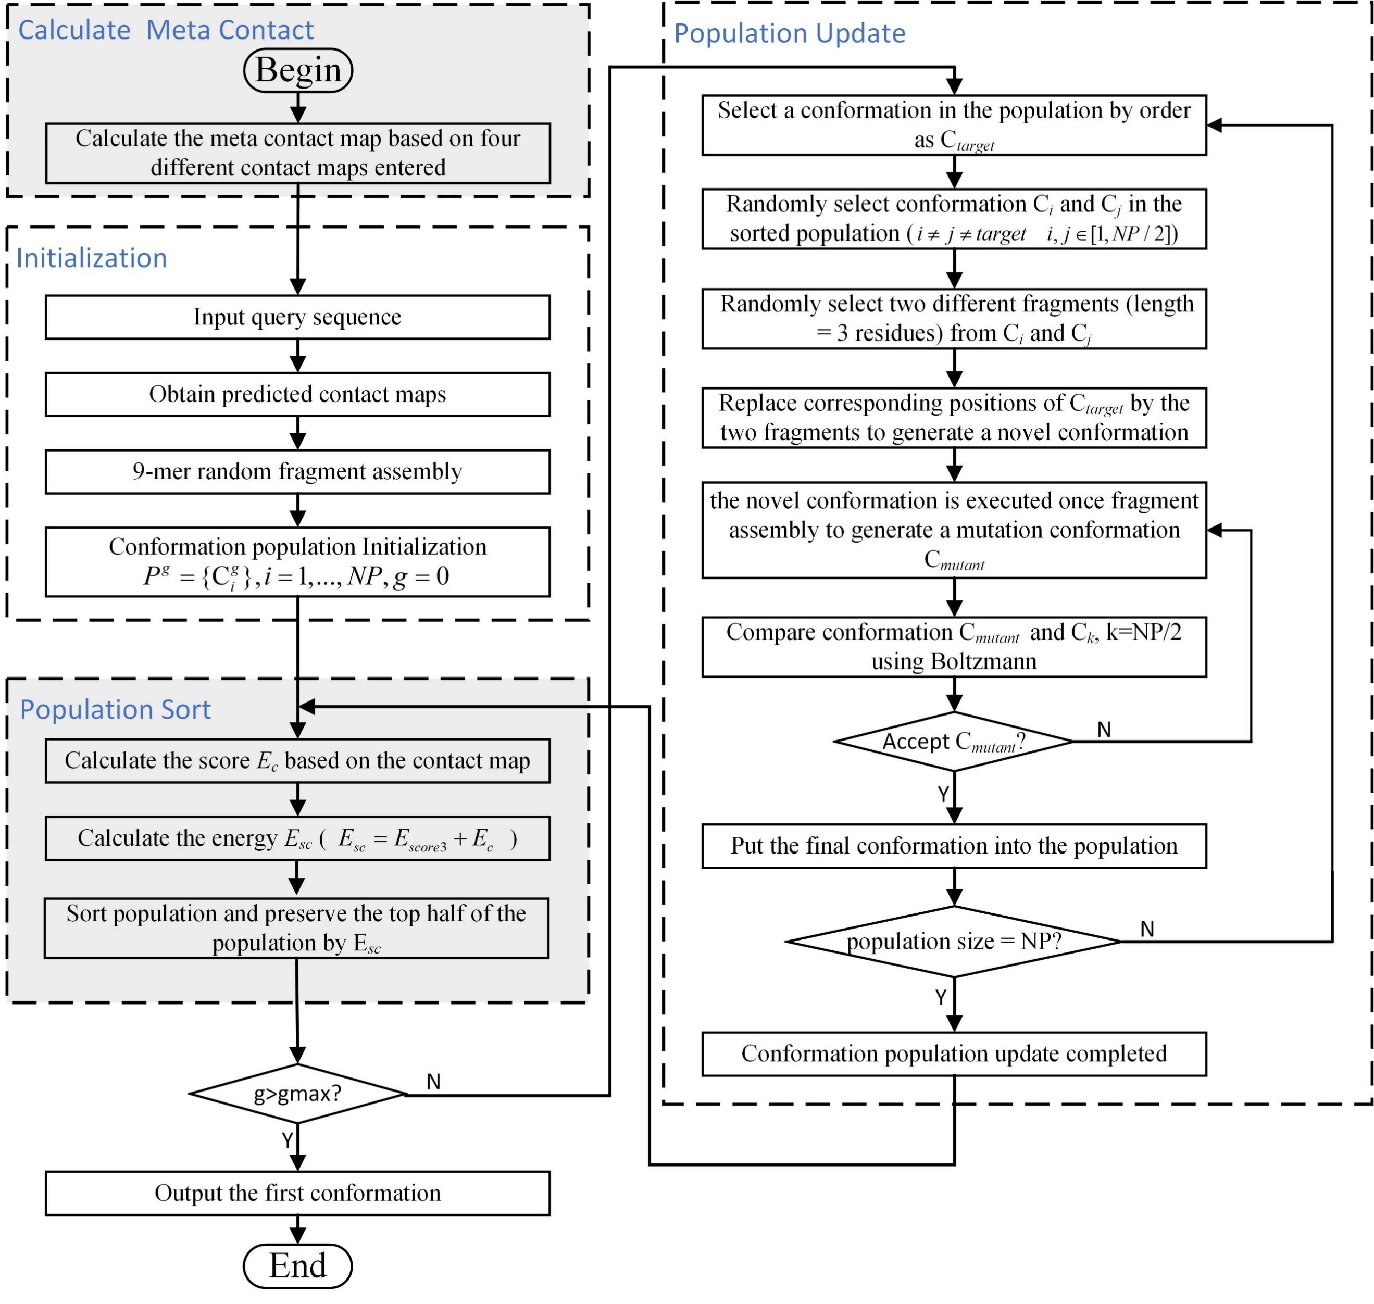

**Figure S4**. Framework of MetaCFold.

In the experiment, both MultiCFold and MetaCFold used four contact maps predicted by different contact predictors (TripletRes, RaptorX-Contact, DeepMetaPSICOV, SPOT-Contact). The difference is that MultiCFold directly uses the thorough information of different contact maps to guide the protein structure folding while MetaCFold combines the four contact maps into a meta-contact map before guiding the structural folding.

We apologize for not explaining clearly the mean of confidence level and the process of generating a meta contact map. Residue-residue contacts are mainly represented by *L*L* matrix, *L* is the length of sequence. Each grid in matrix represents a probability of residue pairs in contact, also referred to as a confidence level. The confidence of each residue pair in meta contact map is obtained by adding up the confidence of each corresponding residue pair in all input contact maps and taking the average value. The calculation of confidence is as follows:

 (S2)

Where *i* and *j* are residue index; is the confidence that the *i*-th residue and the *j*-th residueare in contact. The 3*3 matrix is drawn in Figure R7 for a brief explanation. The contact probability of the first residue and the second residue (the residue pair has been highlighted in the Figure S5) is calculated as follows: .

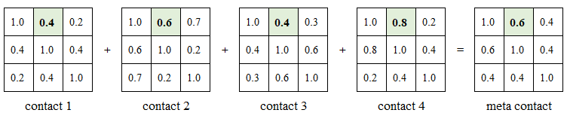

**Figure S5**. A simple example of meta contact generation.

**S4. The relationship between the map quality and folding accuracy.**

A discussion with a figure showing the relationship between the map quality and folding accuracy (see Figure S6). It is not difficult to find that the folding accuracy of the model is improved with the improvement of the contact quality.

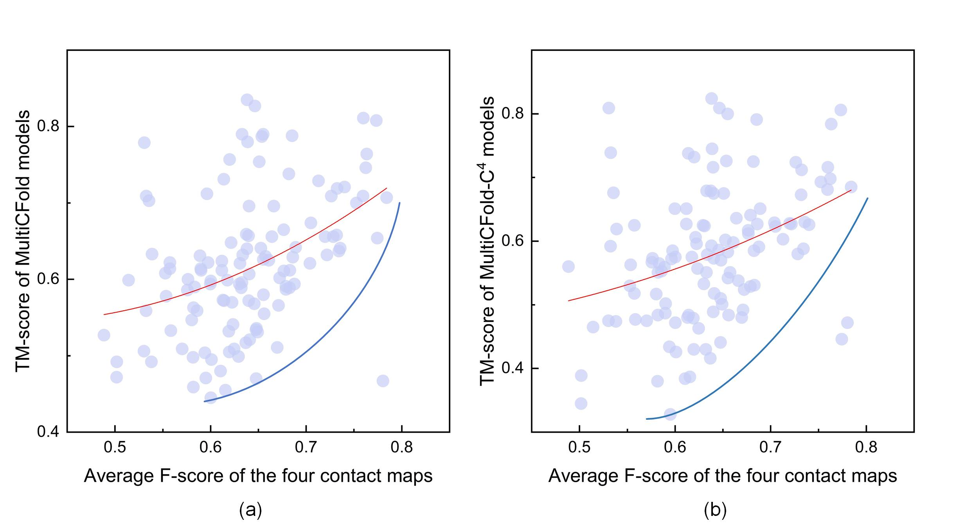

**Figure S6**. The relationship between the map quality and folding accuracy. Figure S6(a) and Figure S6(b) represent the comparison of the map quality with the folding accuracy of MultiCFold and MultiCFold-C4, respectively. The red line represents the data fitting curve, and the blue line represents the approximate change of the minimum folding accuracy as the contact map quality increases.

Referring to the evaluation measures of contact predictions in CASP13, we calculated F-score of the four contact maps of each protein predicted by four severs (TripletRes, RaptorX-Contact, DeepMetaPSICOV, SPOT-Contact). The F-score is defined as the harmonic mean of precision and recall:

 (S1)

where precision and recall are calculated as: ;from the observed true positive (*TP*), false positive (*FP*), and false negative cases (*FN*).

Since the two methods, MultiCFold and MultiCFold-C4, both use four contact maps, it is inappropriate to use F-score of one of the contact maps for comparison. Therefore, we calculated the average F-score of four contact maps as the contact quality. The average F-score is defined as follow:

 (S3)

where *N* is the number of contact predictors; *Fi* is calculated by equation S1.

The average F-score is used to represent the quality of contact map, the relationship between the map quality and folding accuracy of models predicted by MultiCFold and MultiCFold-C4 are depicted in Figure S6 (a) and (b), respectively. As shown in Figure S6, the red line represents the data fitting curve, and the blue line represents the approximate change of the minimum folding accuracy as the contact map quality increases. From these two curves, it is not difficult to find that the folding accuracy of the model is improved with the improvement of the contact quality. In addition, average F-score of the four contact maps for 120 benchmark proteins is shown in Table S5.

**Table S5.** Average F-score of the four contact maps for 120 benchmark proteins.

| NO. | PDB | Average F-score | NO. | PDB | Average F-score | NO. | PDB | Average F-score |
| --- | --- | --- | --- | --- | --- | --- | --- | --- |
| 1 | 1AUU_A | 0.554 | 41 | 1NTV_A | 0.632 | 81 | 2QVG_A | 0.620 |
| 2 | 1B4R_A | 0.514 | 42 | 1OFT_A | 0.676 | 82 | 2QZJ_A | 0.685 |
| 3 | 1BJX_A | 0.664 | 43 | 1OOF_A | 0.689 | 83 | 2RLD_C | 0.760 |
| 4 | 1C03_A | 0.671 | 44 | 1ORY_A | 0.784 | 84 | 2WGP_A | 0.653 |
| 5 | 1C41_A | 0.722 | 45 | 1OX7_A | 0.661 | 85 | 3BDB_A | 0.530 |
| 6 | 1CTO_A | 0.502 | 46 | 1OZ9_A | 0.704 | 86 | 3CG4_A | 0.639 |
| 7 | 1D8B_A | 0.672 | 47 | 1PD6_A | 0.557 | 87 | 3E9T_D | 0.582 |
| 8 | 1DCF_A | 0.633 | 48 | 1PGV_A | 0.640 | 88 | 3EOD_A | 0.654 |
| 9 | 1DWM_A | 0.535 | 49 | 1PSR_A | 0.683 | 89 | 3F8L_A | 0.590 |
| 10 | 1EKZ_A | 0.621 | 50 | 1QMA_A | 0.688 | 90 | 3LQV_B | 0.625 |
| 11 | 1ELW_A | 0.773 | 51 | 1R5T_A | 0.658 | 91 | 3MQK_C | 0.651 |
| 12 | 1EM8_D | 0.613 | 52 | 1S3J_A | 0.752 | 92 | 3N1G_C | 0.533 |
| 13 | 1F43_A | 0.656 | 53 | 1S56_B | 0.720 | 93 | 3N9U_C | 0.640 |
| 14 | 1FCA_A | 0.531 | 54 | 1TAF_A | 0.780 | 94 | 3UE6_E | 0.623 |
| 15 | 1FEX_A | 0.649 | 55 | 1TYG_B | 0.612 | 95 | 3V1O_A | 0.582 |
| 16 | 1FRD_A | 0.580 | 56 | 1UG4_A | 0.502 | 96 | 3W1Z_D | 0.532 |
| 17 | 1FSP_A | 0.638 | 57 | 1VKE_E | 0.734 | 97 | 4AIH_A | 0.736 |
| 18 | 1FW9_A | 0.595 | 58 | 1W1W_E | 0.682 | 98 | 4ASW_C | 0.576 |
| 19 | 1GPQ_B | 0.617 | 59 | 1WJ8_A | 0.763 | 99 | 4ESB_A | 0.728 |
| 20 | 1GQA_A | 0.740 | 60 | 1WMH_B | 0.619 | 100 | 4GF3_A | 0.648 |
| 21 | 1GVP_A | 0.614 | 61 | 1Y1X_A | 0.679 | 101 | 4GQY_A | 0.646 |
| 22 | 1H9E_A | 0.570 | 62 | 2ACY_A | 0.622 | 102 | 4I60_A | 0.629 |
| 23 | 1HBG_A | 0.762 | 63 | 2APN_A | 0.557 | 103 | 4JGX_B | 0.600 |
| 24 | 1HH8_A | 0.679 | 64 | 2AQ0_A | 0.677 | 104 | 4K1F_A | 0.616 |
| 25 | 1HHV_A | 0.553 | 65 | 2BYK_D | 0.774 | 105 | 4KA0_A | 0.612 |
| 26 | 1IUJ_B | 0.640 | 66 | 2CMX_A | 0.655 | 106 | 4LE0_B | 0.646 |
| 27 | 1J8I_A | 0.586 | 67 | 2CWP_A | 0.590 | 107 | 4M75_F | 0.589 |
| 28 | 1J9I_A | 0.655 | 68 | 2EWC_B | 0.597 | 108 | 4MMG_A | 0.637 |
| 29 | 1K1Z_A | 0.488 | 69 | 2F22_B | 0.647 | 109 | 4Q2O_A | 0.558 |
| 30 | 1K3S_A | 0.620 | 70 | 2FA5_B | 0.732 | 110 | 4R67_0 | 0.670 |
| 31 | 1K5D_B | 0.641 | 71 | 2FKB_C | 0.601 | 111 | 4RUV_A | 0.655 |
| 32 | 1KSX_A | 0.640 | 72 | 2GBJ_B | 0.634 | 112 | 4UIJ_A | 0.666 |
| 33 | 1L1D_B | 0.594 | 73 | 2GJ3_A | 0.633 | 113 | 4Z6J_A | 0.600 |
| 34 | 1LFU_P | 0.682 | 74 | 2GKC_A | 0.538 | 114 | 5CJ3_B | 0.583 |
| 35 | 1LNW_C | 0.732 | 75 | 2H30_A | 0.576 | 115 | 5IAO_A | 0.637 |
| 36 | 1LZW_B | 0.713 | 76 | 2HQ7_B | 0.596 | 116 | 5L38_A | 0.705 |
| 37 | 1MAI_A | 0.648 | 77 | 2ICT_A | 0.686 | 117 | 5O2V_A | 0.638 |
| 38 | 1MWQ_A | 0.630 | 78 | 2L74_A | 0.582 | 118 | 5O8G_A | 0.600 |
| 39 | 1N3G_A | 0.631 | 79 | 2NCM_A | 0.539 | 119 | 5T17_A | 0.614 |
| 40 | 1NF6_F | 0.759 | 80 | 2PYB_A | 0.726 | 120 | 5TMF_E | 0.610 |

**S5. CASP and CAMEO experiment.**

1. CASP14 experiment

Based on the reviewer’s valuable suggestions, we added experiments to compare with QUARK, RaptorX-DeepModeller, BAKER-ROSETTASERVER and MULTICOM_CLUSTER on the 18 FM targets of CASP14. The results of the above-mentioned four methods are obtained from the CASP official website (<https://predictioncenter.org/casp14/index.cgi>). Since above four methods are full-version with relax protocol to generate full-atom models, we use Rosetta Fastrelax protocol to generate the full-atom model (MultiCFold-relax) for a fair comparison. Among the predicted models, the average TM-scores of MultiCFold and MultiCFold-relax are 0.413 and 0.453, respectively (see Table S6). On the 18 FM targets of CASP14, the performance of MultiCFold-relax is comparable with the four methods. Meanwhile, in some cases, we found that there are models generated by MultiCFold-relax closer to the native structure (see Table S7). In addition, the TM-score of the final model for each target by above all six methods are illustrated in Figure S7.

**Table S6.** Predicted results of MultiCFold, MultiCFold-relax, QUARK, RaptorX-DeepModeller, BAKER-ROSETTASERVER and MULTICOM_CLUSTER.

|  |  |  |
| --- | --- | --- |
| Methods in CASP14 | TM-score | Correctly Fold |
| MultiCFold-relax | 0.453 | 8 |
| MultiCFold | 0.413 | 3 |
| QUARK | 0.517 | 8 |
| RaptorX-DeepModeller | 0.386 | 3 |
| BAKER-ROSETTASERVER | 0.392 | 5 |
| MULTICOM_CLUSTER | 0.439 | 7 |
| Correctly Fold is the number of the predicted model with TM-score≥0.5. | | |

**Table S7.** Prediction results (TM-score) of MultiCFold, MultiCFold-relax, QUARK, RaptorX-DeepModeller, BAKER-ROSETTASERVER and MULTICOM_CLUSTER for 18 free modeling FM targets of CASP14.

|  |  |  |  |  |  |  |  |  |
| --- | --- | --- | --- | --- | --- | --- | --- | --- |
| No. | PDB | Length | MultiCFold | MultiCFold-relax | Quark | RaptorX-Deep  Modeller | BAKER-ROSETTA  SERVER | MULTI  COM_  CLUSTER |
| 1 | T1027-D1 | 99 | 0.41 | 0.43 | 0.47 | 0.38 | 0.34 | 0.37 |
| 2 | T1029-D1 | 125 | **0.50** | 0.46 | 0.47 | 0.45 | 0.49 | 0.46 |
| 3 | T1031-D1 | 95 | 0.46 | 0.26 | 0.72 | 0.35 | 0.23 | 0.35 |
| 4 | T1033-D1 | 100 | 0.37 | 0.29 | 0.33 | 0.26 | 0.44 | 0.26 |
| 5 | T1035-D1 | 102 | 0.60 | 0.59 | 0.83 | 0.4 | 0.26 | 0.77 |
| 6 | T1037-D1 | 404 | 0.35 | 0.68 | 0.78 | 0.41 | 0.29 | 0.73 |
| 7 | T1038-D1 | 114 | **0.38** | 0.37 | 0.32 | 0.35 | 0.25 | 0.34 |
| 8 | T1038-D2 | 76 | 0.49 | **0.68** | 0.6 | 0.47 | 0.59 | 0.56 |
| 9 | T1039-D1 | 161 | 0.35 | 0.30 | 0.31 | 0.31 | 0.48 | 0.23 |
| 10 | T1040-D1 | 130 | 0.40 | 0.25 | 0.41 | 0.25 | 0.21 | 0.24 |
| 11 | T1042-D1 | 276 | 0.34 | 0.24 | 0.72 | 0.23 | 0.2 | 0.56 |
| 12 | T1043-D1 | 148 | 0.24 | 0.22 | 0.2 | 0.2 | 0.27 | 0.16 |
| 13 | T1046s1-D1 | 72 | 0.67 | 0.72 | 0.69 | 0.73 | 0.74 | 0.69 |
| 14 | T1064-D1 | 92 | **0.29** | 0.28 | 0.25 | 0.22 | 0.25 | 0.25 |
| 15 | T1074-D1 | 132 | 0.40 | **0.58** | 0.48 | 0.4 | 0.54 | 0.43 |
| 16 | T1080-D1 | 133 | 0.34 | **0.50** | 0.37 | 0.34 | 0.27 | 0.39 |
| 17 | T1082-D1 | 75 | 0.48 | 0.58 | 0.7 | 0.52 | 0.63 | 0.55 |
| 18 | T1090-D1 | 189 | 0.36 | **0.72** | 0.65 | 0.68 | 0.57 | 0.56 |

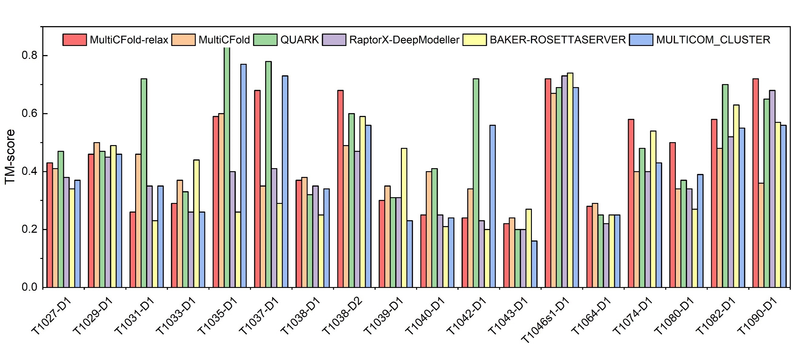

**Figure S7**. TM-score of the predicted model by MultiCFold, MultiCFold-relax, QUARK, RaptorX-DeepModeller, BAKER-ROSETTASERVER and MULTICOM_CLUSTER on the 18 FM targets of CASP14.

1. CAMEO experiment

Based on your valuable suggestions, we added experiments to compare with IntFOLD6-TS, Phyre2, RaptorX and SPARKS-X on the 20 hard recent CAMEO targets. And the details of target proteins, including length, submission date, difficulty on CAMEO, bioassay method and resolution are shown in Table S8.

**Table S8.** The details of 20 hard targets of CAMEO.

| Target ID | Length | Submission Date | Difficulty | Bioassay Method | Resolution |
| --- | --- | --- | --- | --- | --- |
| 6WRW_C | 88 | 2021/4/24 | hard | X-RAY DIFFRACTION | 2.84 |
| 6XL7_A | 119 | 2021/5/1 | hard | X-RAY DIFFRACTION | 1.42 |
| 6XMB_A | 120 | 2021/5/1 | hard | X-RAY DIFFRACTION | 2.31 |
| 6Z5Y_A | 180 | 2021/8/7 | hard | X-RAY DIFFRACTION | 1.01 |
| 6Z6E_A | 160 | 2021/6/5 | hard | X-RAY DIFFRACTION | 1.4 |
| 6ZYC_A | 148 | 2021/5/15 | hard | SOLUTION NMR | 0 |
| 7BPL_A | 110 | 2021/3/20 | hard | SOLUTION NMR | 0 |
| 7BPP_A | 109 | 2021/3/20 | hard | SOLUTION NMR | 0 |
| 7BQD_A | 88 | 2021/3/20 | hard | SOLUTION NMR | 0 |
| 7BQN_A | 121 | 2021/4/3 | hard | SOLUTION NMR | 0 |
| 7BQS_A | 122 | 2021/4/3 | hard | SOLUTION NMR | 0 |
| 7C5V_A | 178 | 2021/4/24 | hard | X-RAY DIFFRACTION | 2.65 |
| 7JZK_B | 151 | 2021/5/22 | hard | X-RAY DIFFRACTION | 2.457 |
| 7K9B_A | 98 | 2021/2/27 | hard | X-RAY DIFFRACTION | 1.202 |
| 7KBQ_A | 135 | 2021/5/15 | hard | SOLUTION NMR | 0 |
| 7L7V_A | 135 | 2021/6/12 | hard | X-RAY DIFFRACTION | 2.95 |
| 7L7W_A | 135 | 2021/6/12 | hard | X-RAY DIFFRACTION | 2.55 |
| 7M5F_C | 143 | 2021/5/8 | hard | X-RAY DIFFRACTION | 1.59 |
| 7NHZ_A | 120 | 2021/3/27 | hard | SOLUTION NMR | 0 |
| 7REF_A | 127 | 2021/8/14 | hard | X-RAY DIFFRACTION | 2.1 |

The results of the above-mentioned four methods are obtained from the CAMEO official website (<https://www.cameo3d.org/modeling/targets/6-months/difficulty/hard/?to_date=2021-09-11>). Among the predicted models, the average TM-scores of MultiCFold, IntFOLD6-TS, Phyre2, RaptorX and SPARKS-X are 0.58, 0.47, 0.30, 0.41 and 0.30, respectively (see Table S9). On the 20 hard targets of CAMEO, the performance of MultiCFold is significantly better than the four methods (see Table S10). In addition, the TM-score of the final model for each target by above all methods are illustrated in Figure S8.

**Table S9.** The average RMSD and TM-score of predicted results of MultiCFold, IntFOLD6-TS, Phyre2, RaptorX and SPARKS-X.

| Methods in CAMO | RMSD | TM-score | Correctly Fold |
| --- | --- | --- | --- |
| MultiCFold | 7.36 | 0.58 | 17 |
| IntFOLD6-TS | 13.76 | 0.47 | 10 |
| Phyre2 | 8.81 | 0.30 | 4 |
| RaptorX | 14.52 | 0.41 | 4 |
| SPARKS-X | 16.68 | 0.30 | 1 |
| #TM≥0.5 is the number of the predicted model with TM-score≥0.5. | | | |
| P-value and Sig (significance) are the results of the Wilcoxon signed rank test. | | | |
| NA represents that there has no data. | | | |

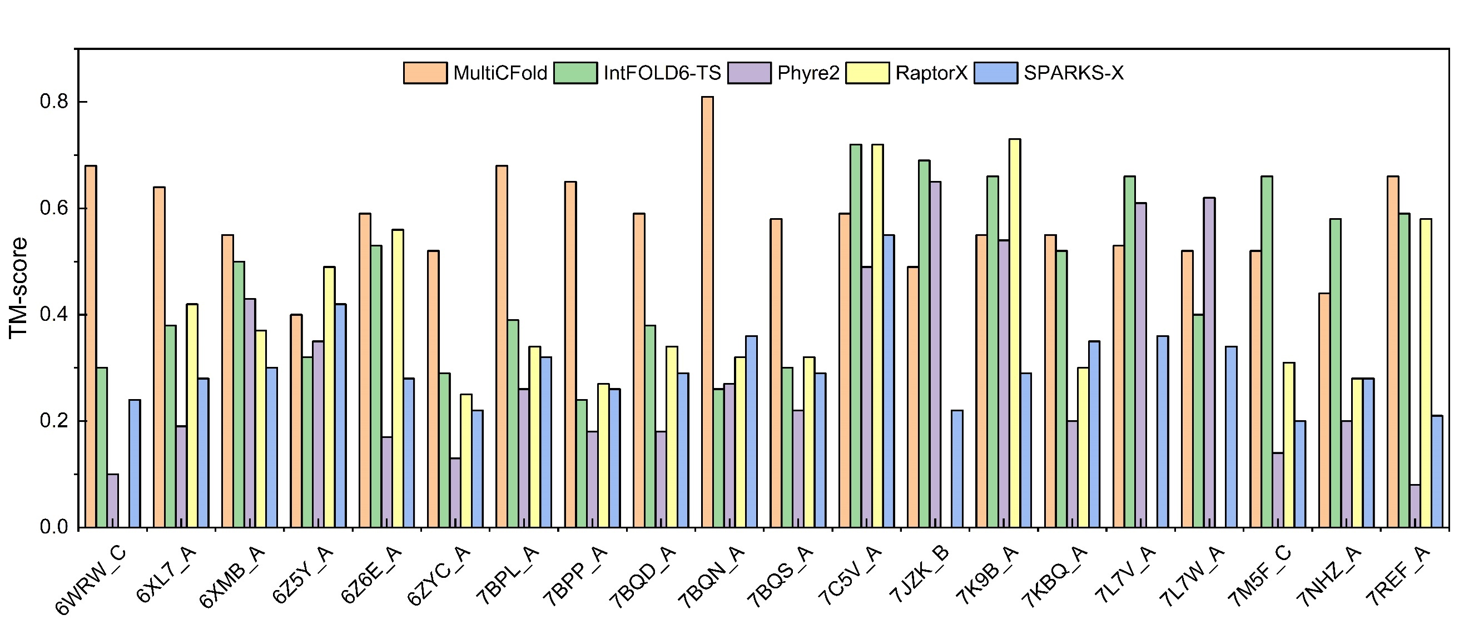

**Figure S8**. TM-score of the predicted model by MultiCFold, IntFOLD6-TS, Phyre2, RaptorX and SPARKS-X on the 20 hard targets of CAMEO.

**Table S10.** Detailed results of MultiCFold, IntFOLD6-TS, Phyre2, RaptorX and SPARKS-X.

| Target ID | MultiCFold | | IntFOLD6-TS | | Phyre2 | | RaptorX | | SPARKS-X | |
| --- | --- | --- | --- | --- | --- | --- | --- | --- | --- | --- |
| RMSD | TMscore | RMSD | TMscore | RMSD | TMscore | RMSD | TMscore | RMSD | TMscore |
| 6WRW_C | 2.86 | **0.68** | 15.22 | 0.30 | 0.43 | 0.10 | NA | NA | 15.29 | 0.24 |
| 6XL7_A | 4.04 | **0.64** | 10.62 | 0.38 | 17.86 | 0.19 | 8.85 | 0.42 | 14.78 | 0.28 |
| 6XMB_A | 16.71 | **0.55** | 15.47 | 0.50 | 3.88 | 0.43 | 17.81 | 0.37 | 20.95 | 0.30 |
| 6Z5Y_A | 11.25 | 0.40 | 15.64 | 0.32 | 4.40 | 0.35 | 8.65 | **0.49** | 13.49 | 0.42 |
| 6Z6E_A | 4.50 | **0.59** | 10.02 | 0.53 | 0.71 | 0.17 | 7.60 | 0.56 | 21.93 | 0.28 |
| 6ZYC_A | 7.55 | **0.52** | 19.03 | 0.29 | 16.86 | 0.13 | 18.62 | 0.25 | 21.07 | 0.22 |
| 7BPL_A | 3.53 | **0.68** | 14.98 | 0.39 | 16.14 | 0.26 | 14.62 | 0.34 | 15.59 | 0.32 |
| 7BPP_A | 5.77 | **0.65** | 19.60 | 0.24 | 3.74 | 0.18 | 18.82 | 0.27 | 21.32 | 0.26 |
| 7BQD_A | 5.77 | **0.59** | 17.35 | 0.38 | 13.08 | 0.18 | 13.84 | 0.34 | 10.88 | 0.29 |
| 7BQN_A | 4.15 | **0.81** | 47.51 | 0.26 | 1.43 | 0.27 | 19.64 | 0.32 | 10.96 | 0.36 |
| 7BQS_A | 15.40 | **0.58** | 15.92 | 0.30 | 19.08 | 0.22 | 14.68 | 0.32 | 25.74 | 0.29 |
| 7C5V_A | 6.43 | 0.59 | 7.43 | **0.72** | 8.43 | 0.49 | 4.82 | **0.72** | 8.36 | 0.55 |
| 7JZK_B | 7.23 | 0.49 | 4.12 | **0.69** | 4.10 | 0.65 | NA | NA | 18.30 | 0.22 |
| 7K9B_A | 5.18 | 0.55 | 4.09 | 0.66 | 6.93 | 0.54 | 3.89 | **0.73** | 13.39 | 0.29 |
| 7KBQ_A | 7.43 | 0.55 | 7.76 | 0.52 | 14.03 | 0.20 | 19.21 | 0.30 | 13.96 | 0.35 |
| 7L7V_A | 5.56 | 0.53 | 7.32 | **0.66** | 4.00 | 0.61 | NA | NA | 12.92 | 0.36 |
| 7L7W_A | 11.22 | 0.52 | 11.72 | 0.40 | 6.37 | **0.62** | NA | NA | 12.05 | 0.34 |
| 7M5F_C | 4.95 | 0.52 | 3.77 | **0.66** | 22.84 | 0.14 | 22.08 | 0.31 | 20.20 | 0.20 |
| 7NHZ_A | 13.05 | 0.44 | 20.70 | **0.58** | 1.52 | 0.20 | 32.76 | 0.28 | 20.47 | 0.28 |
| 7REF_A | 4.53 | **0.66** | 6.83 | 0.59 | 10.35 | 0.08 | 6.46 | 0.58 | 21.86 | 0.21 |
| Average | 7.36 | 0.58 | 13.76 | 0.47 | 8.81 | 0.30 | 14.52 | 0.41 | 16.68 | 0.30 |

**S6. Others.**

**Table S11**. Prediction results of MultiCFold and MetaCFold for 120 benchmark proteins.

| NO. | PDB | Length | Type | MultiCFold | | MetaCFold | |
| --- | --- | --- | --- | --- | --- | --- | --- |
| RMSD | TM-score | RMSD | TM-score |
| 1 | 1AUU_A | 55 | β | 4.987 | 0.578 | 2.49 | 0.832 |
| 2 | 1B4R_A | 80 | β | 4.267 | 0.599 | 4.88 | 0.682 |
| 3 | 1BJX_A | 110 | α/β | 6.089 | 0.656 | 4.14 | 0.797 |
| 4 | 1C03_A | 163 | α/β | 14.040 | 0.566 | 5.01 | 0.451 |
| 5 | 1C41_A | 165 | α/β | 5.258 | 0.632 | 6.25 | 0.552 |
| 6 | 1CTO_A | 109 | β | 6.311 | 0.492 | 3.04 | 0.689 |
| 7 | 1D8B_A | 81 | α | 3.240 | 0.602 | 5.97 | 0.522 |
| 8 | 1DCF_A | 133 | α/β | 4.636 | 0.790 | 6.81 | 0.662 |
| 9 | 1DWM_A | 69 | α/β | 2.479 | 0.703 | 4.67 | 0.659 |
| 10 | 1EKZ_A | 76 | α/β | 6.039 | 0.648 | 5.25 | 0.741 |
| 11 | 1ELW_A | 117 | α | 2.317 | 0.808 | 4.26 | 0.638 |
| 12 | 1EM8_D | 112 | α/β | 6.570 | 0.573 | 4.39 | 0.641 |
| 13 | 1F43_A | 61 | α | 8.081 | 0.555 | 2.43 | 0.723 |
| 14 | 1FCA_A | 55 | α/β | 1.779 | 0.779 | 7.88 | 0.562 |
| 15 | 1FEX_A | 59 | α | 3.476 | 0.531 | 9.14 | 0.457 |
| 16 | 1FRD_A | 98 | α/β | 5.142 | 0.547 | 8.87 | 0.355 |
| 17 | 1FSP_A | 124 | α/β | 3.341 | 0.835 | 2.98 | 0.716 |
| 18 | 1FW9_A | 164 | α/β | 12.994 | 0.471 | 9.08 | 0.344 |
| 19 | 1GPQ_B | 128 | α/β | 4.990 | 0.599 | 8.70 | 0.729 |
| 20 | 1GQA_A | 130 | α/β | 3.650 | 0.721 | 5.16 | 0.741 |
| 21 | 1GVP_A | 87 | α/β | 5.907 | 0.572 | 12.74 | 0.601 |
| 22 | 1H9E_A | 56 | α | 7.858 | 0.509 | 2.57 | 0.839 |
| 23 | 1HBG_A | 147 | α | 3.822 | 0.746 | 3.87 | 0.608 |
| 24 | 1HH8_A | 192 | α/β | 9.589 | 0.587 | 4.99 | 0.694 |
| 25 | 1HHV_A | 74 | α/β | 6.475 | 0.608 | 3.22 | 0.661 |
| 26 | 1IUJ_B | 103 | α/β | 5.100 | 0.696 | 7.52 | 0.504 |
| 27 | 1J8I_A | 93 | α/β | 16.908 | 0.559 | 5.24 | 0.657 |
| 28 | 1J9I_A | 68 | α/β | 5.053 | 0.580 | 5.84 | 0.585 |
| 29 | 1K1Z_A | 78 | β | 4.996 | 0.527 | 4.90 | 0.748 |
| 30 | 1K3S_A | 109 | α/β | 6.438 | 0.505 | 2.67 | 0.691 |
| 31 | 1K5D_B | 146 | α/β | 14.488 | 0.521 | 5.61 | 0.767 |
| 32 | 1KSX_A | 144 | α/β | 6.241 | 0.572 | 4.64 | 0.799 |
| 33 | 1L1D_B | 147 | α/β | 7.596 | 0.504 | 16.70 | 0.351 |
| 34 | 1LFU_P | 82 | α | 5.636 | 0.589 | 7.35 | 0.534 |
| 35 | 1LNW_C | 139 | α/β | 7.994 | 0.719 | 2.53 | 0.668 |
| 36 | 1LZW_B | 146 | α/β | 3.254 | 0.729 | 19.08 | 0.345 |
| 37 | 1MAI_A | 119 | α/β | 5.074 | 0.536 | 13.88 | 0.205 |
| 38 | 1MWQ_A | 99 | α/β | 5.557 | 0.594 | 6.98 | 0.690 |
| 39 | 1N3G_A | 113 | α/β | 8.182 | 0.621 | 4.26 | 0.630 |
| 40 | 1NF6_F | 171 | α/β | 7.006 | 0.709 | 4.74 | 0.682 |
| 41 | 1NTV_A | 152 | α/β | 4.994 | 0.589 | 3.64 | 0.523 |
| 42 | 1OFT_A | 119 | α/β | 3.804 | 0.665 | 10.56 | 0.677 |
| 43 | 1OOF_A | 124 | α/β | 3.861 | 0.642 | 6.33 | 0.648 |
| 44 | 1ORY_A | 119 | α | 3.465 | 0.707 | 2.61 | 0.761 |
| 45 | 1OX7_A | 158 | α/β | 5.122 | 0.625 | 4.41 | 0.700 |
| 46 | 1OZ9_A | 141 | α/β | 5.437 | 0.621 | 12.12 | 0.312 |
| 47 | 1PD6_A | 94 | β | 5.549 | 0.622 | 25.70 | 0.181 |
| 48 | 1PGV_A | 167 | α/β | 4.883 | 0.657 | 8.47 | 0.466 |
| 49 | 1PSR_A | 100 | α/β | 5.900 | 0.612 | 8.80 | 0.572 |
| 50 | 1QMA_A | 123 | α/β | 4.188 | 0.594 | 23.47 | 0.132 |
| 51 | 1R5T_A | 141 | α/β | 5.580 | 0.630 | 8.87 | 0.692 |
| 52 | 1S3J_A | 143 | α/β | 4.871 | 0.700 | 7.80 | 0.560 |
| 53 | 1S56_B | 135 | α/β | 5.095 | 0.656 | 3.83 | 0.757 |
| 54 | 1TAF_A | 68 | α | 8.327 | 0.467 | 9.21 | 0.707 |
| 55 | 1TYG_B | 65 | α/β | 3.107 | 0.612 | 9.23 | 0.568 |
| 56 | 1UG4_A | 60 | β | 6.269 | 0.472 | 3.25 | 0.555 |
| 57 | 1VKE_E | 119 | α | 6.550 | 0.637 | 2.96 | 0.750 |
| 58 | 1W1W_E | 70 | α/β | 2.635 | 0.738 | 1.59 | 0.742 |
| 59 | 1WJ8_A | 117 | α | 2.618 | 0.764 | 2.51 | 0.602 |
| 60 | 1WMH_B | 82 | α/β | 3.869 | 0.532 | 6.97 | 0.679 |
| 61 | 1Y1X_A | 182 | α/β | 9.645 | 0.591 | 3.94 | 0.779 |
| 62 | 2ACY_A | 98 | α/β | 4.187 | 0.570 | 3.57 | 0.770 |
| 63 | 2APN_A | 114 | α/β | 7.173 | 0.614 | 5.36 | 0.679 |
| 64 | 2AQ0_A | 84 | α | 8.913 | 0.611 | 4.12 | 0.659 |
| 65 | 2BYK_D | 92 | α | 4.463 | 0.654 | 2.68 | 0.735 |
| 66 | 2CMX_A | 70 | α/β | 5.191 | 0.626 | 3.24 | 0.815 |
| 67 | 2CWP_A | 109 | α/β | 5.012 | 0.614 | 8.73 | 0.730 |
| 68 | 2EWC_B | 122 | α/β | 4.955 | 0.622 | 2.15 | 0.796 |
| 69 | 2F22_B | 143 | α/β | 9.017 | 0.534 | 8.80 | 0.638 |
| 70 | 2FA5_B | 142 | α/β | 7.472 | 0.658 | 16.13 | 0.541 |
| 71 | 2FKB_C | 167 | α/β | 7.149 | 0.495 | 5.36 | 0.624 |
| 72 | 2GBJ_B | 84 | α/β | 4.368 | 0.632 | 2.76 | 0.766 |
| 73 | 2GJ3_A | 119 | α/β | 4.550 | 0.596 | 16.57 | 0.219 |
| 74 | 2GKC_A | 155 | α/β | 6.828 | 0.492 | 5.53 | 0.669 |
| 75 | 2H30_A | 151 | α/β | 7.446 | 0.600 | 14.97 | 0.509 |
| 76 | 2HQ7_B | 142 | α/β | 4.337 | 0.712 | 1.85 | 0.825 |
| 77 | 2ICT_A | 94 | α | 8.242 | 0.629 | 4.97 | 0.484 |
| 78 | 2L74_A | 125 | α/β | 7.480 | 0.563 | 5.98 | 0.496 |
| 79 | 2NCM_A | 99 | β | 3.538 | 0.633 | 2.08 | 0.852 |
| 80 | 2PYB_A | 151 | α | 4.317 | 0.709 | 17.60 | 0.510 |
| 81 | 2QVG_A | 129 | α/β | 3.556 | 0.757 | 3.52 | 0.692 |
| 82 | 2QZJ_A | 121 | α/β | 2.543 | 0.788 | 18.87 | 0.643 |
| 83 | 2RLD_C | 116 | α | 2.870 | 0.811 | 10.52 | 0.575 |
| 84 | 2WGP_A | 168 | α/β | 7.420 | 0.641 | 6.76 | 0.674 |
| 85 | 3BDB_A | 126 | α/β | 8.704 | 0.506 | 5.61 | 0.679 |
| 86 | 3CG4_A | 126 | α/β | 3.181 | 0.780 | 5.80 | 0.548 |
| 87 | 3E9T_D | 102 | β | 6.181 | 0.459 | 4.50 | 0.544 |
| 88 | 3EOD_A | 115 | α/β | 2.437 | 0.787 | 2.45 | 0.765 |
| 89 | 3F8L_A | 162 | α/β | 6.791 | 0.612 | 6.78 | 0.695 |
| 90 | 3LQV_B | 115 | α/β | 7.209 | 0.509 | 10.20 | 0.298 |
| 91 | 3MQK_C | 75 | β | 2.178 | 0.754 | 5.40 | 0.703 |
| 92 | 3N1G_C | 104 | α/β | 4.024 | 0.709 | 2.96 | 0.792 |
| 93 | 3N9U_C | 96 | α/β | 4.463 | 0.607 | 6.22 | 0.605 |
| 94 | 3UE6_E | 138 | α/β | 6.613 | 0.541 | 2.42 | 0.818 |
| 95 | 3V1O_A | 165 | α/β | 8.259 | 0.498 | 9.85 | 0.669 |
| 96 | 3W1Z_D | 110 | α/β | 10.222 | 0.559 | 10.46 | 0.482 |
| 97 | 4AIH_A | 139 | α/β | 5.148 | 0.641 | 5.66 | 0.528 |
| 98 | 4ASW_C | 81 | α/β | 4.099 | 0.586 | 4.47 | 0.574 |
| 99 | 4ESB_A | 103 | α/β | 5.650 | 0.656 | 3.54 | 0.696 |
| 100 | 4GF3_A | 123 | α/β | 8.490 | 0.470 | 5.08 | 0.641 |
| 101 | 4GQY_A | 147 | α/β | 8.510 | 0.568 | 13.84 | 0.311 |
| 102 | 4I60_A | 128 | α/β | 6.757 | 0.499 | 4.44 | 0.707 |
| 103 | 4JGX_B | 128 | α/β | 4.891 | 0.594 | 2.94 | 0.798 |
| 104 | 4K1F_A | 198 | α/β | 8.590 | 0.455 | 3.28 | 0.722 |
| 105 | 4KA0_A | 143 | α/β | 4.585 | 0.624 | 15.24 | 0.531 |
| 106 | 4LE0_B | 133 | α/β | 2.152 | 0.827 | 7.92 | 0.501 |
| 107 | 4M75_F | 75 | α/β | 7.198 | 0.631 | 6.26 | 0.536 |
| 108 | 4MMG_A | 91 | α/β | 3.685 | 0.659 | 3.32 | 0.684 |
| 109 | 4Q2O_A | 92 | α/β | 6.865 | 0.533 | 11.87 | 0.736 |
| 110 | 4R67_0 | 199 | α/β | 7.977 | 0.511 | 6.68 | 0.471 |
| 111 | 4RUV_A | 106 | α/β | 2.314 | 0.790 | 5.75 | 0.561 |
| 112 | 4UIJ_A | 104 | α/β | 3.359 | 0.696 | 3.54 | 0.577 |
| 113 | 4Z6J_A | 133 | β | 9.398 | 0.445 | 6.60 | 0.739 |
| 114 | 5CJ3_B | 126 | α/β | 6.680 | 0.590 | 12.89 | 0.267 |
| 115 | 5IAO_A | 171 | α/β | 7.447 | 0.517 | 3.36 | 0.671 |
| 116 | 5L38_A | 91 | α/β | 3.492 | 0.674 | 9.08 | 0.667 |
| 117 | 5O2V_A | 92 | α/β | 5.794 | 0.640 | 2.76 | 0.782 |
| 118 | 5O8G_A | 122 | α/β | 5.940 | 0.598 | 9.89 | 0.507 |
| 119 | 5T17_A | 85 | α/β | 2.441 | 0.731 | 2.64 | 0.813 |
| 120 | 5TMF_E | 95 | α/β | 6.406 | 0.480 | 10.37 | 0.498 |

**Table S12**. Prediction results of MultiCFold-C4, MultiCFold-, MultiCFold-, MultiCFold-, and MultiCFold- for 120 benchmark proteins.

| NO. | PDB | MultiCFold-C4 | | MultiCFold- | | MultiCFold- | | MultiCFold- | | MultiCFold- | |
| --- | --- | --- | --- | --- | --- | --- | --- | --- | --- | --- | --- |
| RMSD | TM-score | RMSD | TM-score | RMSD | TM-score | RMSD | TM-score | RMSD | TM-score |
| 1 | 1AUU_A | 4.99 | 0.58 | 5.55 | 0.48 | 6.10 | 0.43 | 4.22 | 0.49 | 5.82 | 0.44 |
| 2 | 1B4R_A | 4.27 | 0.60 | 9.92 | 0.41 | 6.49 | 0.43 | 6.99 | 0.31 | 5.50 | 0.37 |
| 3 | 1BJX_A | 6.09 | 0.66 | 5.54 | 0.59 | 4.69 | 0.68 | 6.84 | 0.52 | 8.46 | 0.49 |
| 4 | 1C03_A | 14.04 | 0.57 | 10.10 | 0.51 | 15.01 | 0.46 | 9.74 | 0.61 | 12.58 | 0.43 |
| 5 | 1C41_A | 5.26 | 0.63 | 4.33 | 0.71 | 6.34 | 0.55 | 6.10 | 0.62 | 5.51 | 0.57 |
| 6 | 1CTO_A | 6.31 | 0.49 | 7.55 | 0.35 | 10.71 | 0.32 | 9.49 | 0.37 | 11.83 | 0.24 |
| 7 | 1D8B_A | 3.24 | 0.60 | 7.54 | 0.33 | 5.73 | 0.41 | 3.60 | 0.60 | 4.23 | 0.55 |
| 8 | 1DCF_A | 4.64 | 0.79 | 4.00 | 0.63 | 6.48 | 0.53 | 4.42 | 0.68 | 4.18 | 0.69 |
| 9 | 1DWM_A | 2.48 | 0.70 | 5.39 | 0.67 | 5.01 | 0.56 | 4.06 | 0.63 | 6.66 | 0.58 |
| 10 | 1EKZ_A | 6.04 | 0.65 | 5.45 | 0.56 | 6.08 | 0.56 | 5.63 | 0.58 | 5.84 | 0.60 |
| 11 | 1ELW_A | 2.32 | 0.81 | 3.12 | 0.71 | 3.32 | 0.71 | 3.66 | 0.66 | 3.77 | 0.64 |
| 12 | 1EM8_D | 6.57 | 0.57 | 6.78 | 0.44 | 5.66 | 0.46 | 7.09 | 0.41 | 6.96 | 0.41 |
| 13 | 1F43_A | 8.08 | 0.56 | 8.71 | 0.41 | 8.42 | 0.48 | 6.77 | 0.43 | 8.69 | 0.44 |
| 14 | 1FCA_A | 1.78 | 0.78 | 2.61 | 0.66 | 3.69 | 0.58 | 2.23 | 0.67 | 2.17 | 0.68 |
| 15 | 1FEX_A | 3.48 | 0.53 | 3.86 | 0.43 | 3.66 | 0.50 | 4.28 | 0.42 | 3.73 | 0.47 |
| 16 | 1FRD_A | 5.14 | 0.55 | 10.46 | 0.40 | 8.48 | 0.37 | 12.00 | 0.35 | 9.32 | 0.40 |
| 17 | 1FSP_A | 3.34 | 0.83 | 3.45 | 0.76 | 4.19 | 0.79 | 3.74 | 0.75 | 3.79 | 0.74 |
| 18 | 1FW9_A | 12.99 | 0.47 | 11.71 | 0.40 | 11.35 | 0.41 | 11.37 | 0.39 | 11.63 | 0.45 |
| 19 | 1GPQ_B | 4.99 | 0.60 | 8.50 | 0.46 | 7.79 | 0.50 | 4.58 | 0.61 | 8.19 | 0.51 |
| 20 | 1GQA_A | 3.65 | 0.72 | 4.73 | 0.58 | 5.13 | 0.57 | 6.39 | 0.62 | 7.53 | 0.53 |
| 21 | 1GVP_A | 5.91 | 0.57 | 6.45 | 0.44 | 7.80 | 0.41 | 7.59 | 0.50 | 5.20 | 0.52 |
| 22 | 1H9E_A | 7.86 | 0.51 | 7.76 | 0.43 | 11.34 | 0.39 | 5.82 | 0.50 | 7.62 | 0.40 |
| 23 | 1HBG_A | 3.82 | 0.75 | 4.50 | 0.60 | 6.71 | 0.56 | 3.75 | 0.70 | 3.67 | 0.72 |
| 24 | 1HH8_A | 9.59 | 0.59 | 16.96 | 0.54 | 13.73 | 0.46 | 7.52 | 0.55 | 13.35 | 0.46 |
| 25 | 1HHV_A | 6.48 | 0.61 | 9.58 | 0.53 | 9.76 | 0.39 | 11.49 | 0.42 | 11.29 | 0.44 |
| 26 | 1IUJ_B | 5.10 | 0.70 | 4.27 | 0.67 | 4.73 | 0.59 | 5.64 | 0.59 | 5.42 | 0.56 |
| 27 | 1J8I_A | 16.91 | 0.56 | 17.66 | 0.50 | 17.55 | 0.51 | 18.14 | 0.52 | 18.50 | 0.47 |
| 28 | 1J9I_A | 5.05 | 0.58 | 9.76 | 0.37 | 4.78 | 0.55 | 9.92 | 0.36 | 6.08 | 0.52 |
| 29 | 1K1Z_A | 5.00 | 0.53 | 8.88 | 0.45 | 12.44 | 0.42 | 6.34 | 0.48 | 5.96 | 0.46 |
| 30 | 1K3S_A | 6.44 | 0.50 | 10.54 | 0.34 | 7.01 | 0.43 | 11.92 | 0.32 | 12.92 | 0.33 |
| 31 | 1K5D_B | 14.49 | 0.52 | 14.50 | 0.33 | 10.26 | 0.46 | 13.58 | 0.40 | 16.05 | 0.47 |
| 32 | 1KSX_A | 6.24 | 0.57 | 7.63 | 0.48 | 6.15 | 0.49 | 5.82 | 0.53 | 6.95 | 0.52 |
| 33 | 1L1D_B | 7.60 | 0.50 | 12.04 | 0.32 | 14.14 | 0.25 | 8.86 | 0.33 | 9.71 | 0.38 |
| 34 | 1LFU_P | 5.64 | 0.59 | 6.21 | 0.52 | 11.18 | 0.47 | 4.82 | 0.54 | 8.27 | 0.49 |
| 35 | 1LNW_C | 7.99 | 0.72 | 6.17 | 0.58 | 7.43 | 0.62 | 6.35 | 0.60 | 10.23 | 0.61 |
| 36 | 1LZW_B | 3.25 | 0.73 | 5.40 | 0.67 | 5.35 | 0.69 | 5.83 | 0.66 | 4.89 | 0.66 |
| 37 | 1MAI_A | 5.07 | 0.54 | 9.69 | 0.39 | 6.94 | 0.48 | 14.09 | 0.29 | 8.44 | 0.40 |
| 38 | 1MWQ_A | 5.56 | 0.59 | 9.99 | 0.42 | 13.32 | 0.28 | 5.07 | 0.57 | 5.59 | 0.55 |
| 39 | 1N3G_A | 8.18 | 0.62 | 5.64 | 0.57 | 9.34 | 0.49 | 6.17 | 0.53 | 7.97 | 0.53 |
| 40 | 1NF6_F | 7.01 | 0.71 | 9.26 | 0.61 | 7.59 | 0.59 | 9.94 | 0.67 | 5.29 | 0.68 |
| 41 | 1NTV_A | 4.99 | 0.59 | 8.41 | 0.37 | 8.95 | 0.50 | 12.81 | 0.29 | 9.41 | 0.36 |
| 42 | 1OFT_A | 3.80 | 0.67 | 4.53 | 0.57 | 4.16 | 0.59 | 3.81 | 0.64 | 3.70 | 0.64 |
| 43 | 1OOF_A | 3.86 | 0.64 | 5.78 | 0.50 | 6.92 | 0.43 | 3.32 | 0.66 | 3.98 | 0.62 |
| 44 | 1ORY_A | 3.47 | 0.71 | 3.62 | 0.66 | 3.80 | 0.60 | 4.14 | 0.65 | 3.66 | 0.64 |
| 45 | 1OX7_A | 5.12 | 0.62 | 13.01 | 0.33 | 6.99 | 0.44 | 6.43 | 0.52 | 6.35 | 0.53 |
| 46 | 1OZ9_A | 5.44 | 0.62 | 8.69 | 0.45 | 4.88 | 0.56 | 6.47 | 0.52 | 12.34 | 0.47 |
| 47 | 1PD6_A | 5.55 | 0.62 | 5.12 | 0.53 | 5.55 | 0.50 | 5.32 | 0.51 | 4.67 | 0.63 |
| 48 | 1PGV_A | 4.88 | 0.66 | 10.78 | 0.53 | 5.28 | 0.64 | 6.51 | 0.59 | 5.84 | 0.65 |
| 49 | 1PSR_A | 5.90 | 0.61 | 6.44 | 0.42 | 7.25 | 0.47 | 5.39 | 0.51 | 6.63 | 0.45 |
| 50 | 1QMA_A | 4.19 | 0.59 | 5.18 | 0.57 | 5.24 | 0.51 | 5.14 | 0.59 | 5.67 | 0.58 |
| 51 | 1R5T_A | 5.58 | 0.63 | 7.08 | 0.55 | 6.22 | 0.53 | 7.71 | 0.46 | 7.53 | 0.49 |
| 52 | 1S3J_A | 4.87 | 0.70 | 8.03 | 0.57 | 7.09 | 0.57 | 5.43 | 0.70 | 8.08 | 0.64 |
| 53 | 1S56_B | 5.10 | 0.66 | 8.99 | 0.56 | 7.70 | 0.57 | 9.16 | 0.55 | 9.71 | 0.55 |
| 54 | 1TAF_A | 8.33 | 0.47 | 8.75 | 0.42 | 6.22 | 0.37 | 9.10 | 0.43 | 8.31 | 0.43 |
| 55 | 1TYG_B | 3.11 | 0.61 | 4.21 | 0.51 | 9.77 | 0.32 | 4.20 | 0.49 | 4.62 | 0.56 |
| 56 | 1UG4_A | 6.27 | 0.47 | 8.28 | 0.32 | 8.92 | 0.20 | 8.48 | 0.28 | 6.95 | 0.30 |
| 57 | 1VKE_E | 6.55 | 0.64 | 9.01 | 0.56 | 6.45 | 0.53 | 7.03 | 0.60 | 6.06 | 0.53 |
| 58 | 1W1W_E | 2.64 | 0.74 | 4.23 | 0.57 | 3.12 | 0.66 | 3.13 | 0.57 | 3.09 | 0.63 |
| 59 | 1WJ8_A | 2.62 | 0.76 | 2.75 | 0.75 | 3.58 | 0.66 | 2.86 | 0.75 | 3.50 | 0.67 |
| 60 | 1WMH_B | 3.87 | 0.53 | 6.18 | 0.47 | 9.50 | 0.30 | 4.96 | 0.46 | 5.74 | 0.39 |
| 61 | 1Y1X_A | 9.65 | 0.59 | 8.96 | 0.46 | 9.19 | 0.55 | 7.48 | 0.51 | 8.99 | 0.59 |
| 62 | 2ACY_A | 4.19 | 0.57 | 5.56 | 0.49 | 6.99 | 0.42 | 6.63 | 0.47 | 6.40 | 0.41 |
| 63 | 2APN_A | 7.17 | 0.61 | 8.41 | 0.44 | 6.70 | 0.49 | 7.09 | 0.53 | 7.97 | 0.45 |
| 64 | 2AQ0_A | 8.91 | 0.61 | 11.66 | 0.51 | 10.79 | 0.50 | 8.02 | 0.52 | 10.76 | 0.51 |
| 65 | 2BYK_D | 4.46 | 0.65 | 10.91 | 0.41 | 6.77 | 0.39 | 7.31 | 0.45 | 11.63 | 0.42 |
| 66 | 2CMX_A | 5.19 | 0.63 | 4.53 | 0.47 | 3.16 | 0.60 | 2.51 | 0.65 | 5.08 | 0.46 |
| 67 | 2CWP_A | 5.01 | 0.61 | 9.01 | 0.37 | 13.52 | 0.33 | 9.12 | 0.39 | 8.60 | 0.40 |
| 68 | 2EWC_B | 4.96 | 0.62 | 8.52 | 0.43 | 14.49 | 0.25 | 8.79 | 0.42 | 5.14 | 0.53 |
| 69 | 2F22_B | 9.02 | 0.53 | 10.07 | 0.39 | 7.65 | 0.40 | 6.57 | 0.49 | 6.73 | 0.47 |
| 70 | 2FA5_B | 7.47 | 0.66 | 10.74 | 0.51 | 8.75 | 0.63 | 7.33 | 0.58 | 12.86 | 0.62 |
| 71 | 2FKB_C | 7.15 | 0.49 | 9.14 | 0.43 | 14.21 | 0.25 | 11.49 | 0.32 | 15.93 | 0.27 |
| 72 | 2GBJ_B | 4.37 | 0.63 | 5.87 | 0.50 | 7.79 | 0.49 | 5.95 | 0.51 | 6.33 | 0.49 |
| 73 | 2GJ3_A | 4.55 | 0.60 | 5.43 | 0.60 | 7.29 | 0.41 | 7.10 | 0.50 | 5.96 | 0.54 |
| 74 | 2GKC_A | 6.83 | 0.49 | 9.80 | 0.32 | 14.91 | 0.25 | 7.59 | 0.45 | 8.13 | 0.45 |
| 75 | 2H30_A | 7.45 | 0.60 | 8.71 | 0.47 | 9.18 | 0.52 | 9.08 | 0.50 | 8.05 | 0.53 |
| 76 | 2HQ7_B | 4.34 | 0.71 | 4.50 | 0.65 | 13.53 | 0.42 | 7.38 | 0.52 | 6.92 | 0.50 |
| 77 | 2ICT_A | 8.24 | 0.63 | 8.41 | 0.51 | 8.22 | 0.59 | 7.48 | 0.58 | 10.76 | 0.47 |
| 78 | 2L74_A | 7.48 | 0.56 | 7.58 | 0.50 | 9.82 | 0.51 | 7.94 | 0.54 | 6.54 | 0.55 |
| 79 | 2NCM_A | 3.54 | 0.63 | 6.19 | 0.43 | 7.56 | 0.51 | 7.06 | 0.43 | 6.08 | 0.58 |
| 80 | 2PYB_A | 4.32 | 0.71 | 4.63 | 0.66 | 4.56 | 0.65 | 4.95 | 0.59 | 5.72 | 0.61 |
| 81 | 2QVG_A | 3.56 | 0.76 | 3.73 | 0.69 | 3.85 | 0.66 | 3.82 | 0.67 | 3.82 | 0.68 |
| 82 | 2QZJ_A | 2.54 | 0.79 | 2.56 | 0.80 | 4.24 | 0.63 | 3.13 | 0.70 | 2.73 | 0.76 |
| 83 | 2RLD_C | 2.87 | 0.81 | 4.16 | 0.72 | 3.52 | 0.70 | 3.47 | 0.71 | 8.35 | 0.54 |
| 84 | 2WGP_A | 7.42 | 0.64 | 7.29 | 0.55 | 10.24 | 0.55 | 8.32 | 0.54 | 6.90 | 0.59 |
| 85 | 3BDB_A | 8.70 | 0.51 | 12.20 | 0.30 | 17.79 | 0.23 | 10.43 | 0.33 | 9.64 | 0.41 |
| 86 | 3CG4_A | 3.18 | 0.78 | 3.17 | 0.75 | 3.79 | 0.68 | 3.44 | 0.72 | 3.34 | 0.73 |
| 87 | 3E9T_D | 6.18 | 0.46 | 6.00 | 0.40 | 8.16 | 0.30 | 7.70 | 0.33 | 8.10 | 0.39 |
| 88 | 3EOD_A | 2.44 | 0.79 | 5.46 | 0.63 | 3.49 | 0.64 | 2.82 | 0.70 | 4.02 | 0.61 |
| 89 | 3F8L_A | 6.79 | 0.61 | 11.53 | 0.36 | 12.95 | 0.35 | 5.73 | 0.61 | 14.25 | 0.35 |
| 90 | 3LQV_B | 7.21 | 0.51 | 8.11 | 0.48 | 13.48 | 0.39 | 11.04 | 0.48 | 8.70 | 0.49 |
| 91 | 3MQK_C | 2.18 | 0.75 | 4.49 | 0.53 | 2.36 | 0.71 | 2.62 | 0.69 | 3.00 | 0.63 |
| 92 | 3N1G_C | 4.02 | 0.71 | 5.09 | 0.58 | 7.86 | 0.42 | 11.25 | 0.31 | 5.92 | 0.53 |
| 93 | 3N9U_C | 4.46 | 0.61 | 8.34 | 0.62 | 9.22 | 0.55 | 8.19 | 0.58 | 5.91 | 0.48 |
| 94 | 3UE6_E | 6.61 | 0.54 | 7.68 | 0.45 | 10.07 | 0.46 | 6.59 | 0.55 | 9.23 | 0.46 |
| 95 | 3V1O_A | 8.26 | 0.50 | 11.21 | 0.38 | 12.52 | 0.32 | 11.05 | 0.37 | 11.46 | 0.34 |
| 96 | 3W1Z_D | 10.22 | 0.56 | 7.59 | 0.52 | 14.65 | 0.35 | 10.82 | 0.45 | 15.42 | 0.44 |
| 97 | 4AIH_A | 5.15 | 0.64 | 6.80 | 0.51 | 7.48 | 0.53 | 6.96 | 0.52 | 7.10 | 0.56 |
| 98 | 4ASW_C | 4.10 | 0.59 | 4.80 | 0.52 | 7.58 | 0.45 | 5.64 | 0.46 | 4.50 | 0.54 |
| 99 | 4ESB_A | 5.65 | 0.66 | 6.08 | 0.61 | 6.13 | 0.65 | 5.83 | 0.59 | 8.62 | 0.55 |
| 100 | 4GF3_A | 8.49 | 0.47 | 8.91 | 0.37 | 9.82 | 0.43 | 12.45 | 0.29 | 10.11 | 0.42 |
| 101 | 4GQY_A | 8.51 | 0.57 | 8.95 | 0.46 | 9.70 | 0.47 | 10.05 | 0.45 | 7.30 | 0.51 |
| 102 | 4I60_A | 6.76 | 0.50 | 7.95 | 0.45 | 8.75 | 0.44 | 14.48 | 0.30 | 6.63 | 0.47 |
| 103 | 4JGX_B | 4.89 | 0.59 | 5.26 | 0.57 | 6.65 | 0.55 | 5.67 | 0.52 | 5.43 | 0.59 |
| 104 | 4K1F_A | 8.59 | 0.46 | 11.76 | 0.37 | 17.10 | 0.30 | 17.07 | 0.26 | 12.70 | 0.31 |
| 105 | 4KA0_A | 4.59 | 0.62 | 5.00 | 0.57 | 11.54 | 0.40 | 4.47 | 0.61 | 5.40 | 0.54 |
| 106 | 4LE0_B | 2.15 | 0.83 | 3.11 | 0.77 | 3.51 | 0.75 | 3.33 | 0.77 | 2.51 | 0.78 |
| 107 | 4M75_F | 7.20 | 0.63 | 9.17 | 0.56 | 9.31 | 0.36 | 6.50 | 0.62 | 7.85 | 0.62 |
| 108 | 4MMG_A | 3.69 | 0.66 | 5.40 | 0.52 | 3.59 | 0.64 | 3.94 | 0.59 | 4.53 | 0.56 |
| 109 | 4Q2O_A | 6.87 | 0.53 | 11.54 | 0.36 | 10.13 | 0.41 | 11.35 | 0.47 | 7.83 | 0.40 |
| 110 | 4R67_0 | 7.98 | 0.51 | 13.58 | 0.34 | 8.22 | 0.42 | 11.96 | 0.43 | 16.34 | 0.35 |
| 111 | 4RUV_A | 2.31 | 0.79 | 3.07 | 0.70 | 2.82 | 0.73 | 2.40 | 0.76 | 2.71 | 0.73 |
| 112 | 4UIJ_A | 3.36 | 0.70 | 3.79 | 0.61 | 5.53 | 0.53 | 3.97 | 0.62 | 7.98 | 0.52 |
| 113 | 4Z6J_A | 9.40 | 0.45 | 11.04 | 0.34 | 9.85 | 0.34 | 14.03 | 0.25 | 7.77 | 0.41 |
| 114 | 5CJ3_B | 6.68 | 0.59 | 8.75 | 0.44 | 6.74 | 0.52 | 5.87 | 0.63 | 6.85 | 0.56 |
| 115 | 5IAO_A | 7.45 | 0.52 | 13.44 | 0.27 | 8.02 | 0.51 | 12.98 | 0.29 | 13.85 | 0.27 |
| 116 | 5L38_A | 3.49 | 0.67 | 3.38 | 0.73 | 4.17 | 0.63 | 2.92 | 0.64 | 4.21 | 0.57 |
| 117 | 5O2V_A | 5.79 | 0.64 | 6.53 | 0.57 | 5.33 | 0.65 | 4.22 | 0.65 | 5.71 | 0.54 |
| 118 | 5O8G_A | 5.94 | 0.60 | 7.17 | 0.51 | 8.20 | 0.39 | 9.81 | 0.40 | 8.73 | 0.46 |
| 119 | 5T17_A | 2.44 | 0.73 | 2.50 | 0.73 | 2.89 | 0.68 | 2.74 | 0.70 | 2.66 | 0.71 |
| 120 | 5TMF_E | 6.41 | 0.48 | 10.68 | 0.40 | 11.84 | 0.35 | 8.77 | 0.34 | 9.99 | 0.35 |

**Table S13**. Prediction results of MultiCFold and MultiCFold-C4 for 120 benchmark proteins.

| NO. | PDB | Length | Type | MultiCFold | | MultiCFold-C4 | |
| --- | --- | --- | --- | --- | --- | --- | --- |
| RMSD | TM-score | RMSD | TM-score |
| 1 | 1AUU_A | 55 | β | 4.987 | 0.578 | 4.452 | 0.563 |
| 2 | 1B4R_A | 80 | β | 4.267 | 0.599 | 4.957 | 0.465 |
| 3 | 1BJX_A | 110 | α/β | 6.089 | 0.656 | 7.974 | 0.636 |
| 4 | 1C03_A | 163 | α/β | 14.040 | 0.566 | 11.985 | 0.492 |
| 5 | 1C41_A | 165 | α/β | 5.258 | 0.632 | 5.126 | 0.627 |
| 6 | 1CTO_A | 109 | β | 6.311 | 0.492 | 7.177 | 0.389 |
| 7 | 1D8B_A | 81 | α | 3.240 | 0.602 | 3.975 | 0.524 |
| 8 | 1DCF_A | 133 | α/β | 4.636 | 0.790 | 4.245 | 0.679 |
| 9 | 1DWM_A | 69 | α/β | 2.479 | 0.703 | 2.797 | 0.676 |
| 10 | 1EKZ_A | 76 | α/β | 6.039 | 0.648 | 6.277 | 0.606 |
| 11 | 1ELW_A | 117 | α | 2.317 | 0.808 | 2.287 | 0.806 |
| 12 | 1EM8_D | 112 | α/β | 6.570 | 0.573 | 6.180 | 0.480 |
| 13 | 1F43_A | 61 | α | 8.081 | 0.555 | 7.130 | 0.484 |
| 14 | 1FCA_A | 55 | α/β | 1.779 | 0.779 | 1.440 | 0.809 |
| 15 | 1FEX_A | 59 | α | 3.476 | 0.531 | 3.509 | 0.501 |
| 16 | 1FRD_A | 98 | α/β | 5.142 | 0.547 | 4.906 | 0.517 |
| 17 | 1FSP_A | 124 | α/β | 3.341 | 0.835 | 3.246 | 0.824 |
| 18 | 1FW9_A | 164 | α/β | 12.994 | 0.471 | 12.880 | 0.328 |
| 19 | 1GPQ_B | 128 | α/β | 4.990 | 0.599 | 7.882 | 0.575 |
| 20 | 1GQA_A | 130 | α/β | 3.650 | 0.721 | 7.022 | 0.626 |
| 21 | 1GVP_A | 87 | α/β | 5.907 | 0.572 | 6.293 | 0.484 |
| 22 | 1H9E_A | 56 | α | 7.858 | 0.509 | 8.246 | 0.475 |
| 23 | 1HBG_A | 147 | α | 3.822 | 0.746 | 3.691 | 0.698 |
| 24 | 1HH8_A | 192 | α/β | 9.589 | 0.587 | 9.443 | 0.529 |
| 25 | 1HHV_A | 74 | α/β | 6.475 | 0.608 | 10.398 | 0.530 |
| 26 | 1IUJ_B | 103 | α/β | 5.100 | 0.696 | 4.794 | 0.675 |
| 27 | 1J8I_A | 93 | α/β | 16.908 | 0.559 | 17.376 | 0.553 |
| 28 | 1J9I_A | 68 | α/β | 5.053 | 0.580 | 6.389 | 0.542 |
| 29 | 1K1Z_A | 78 | β | 4.996 | 0.527 | 5.335 | 0.560 |
| 30 | 1K3S_A | 109 | α/β | 6.438 | 0.505 | 8.528 | 0.430 |
| 31 | 1K5D_B | 146 | α/β | 14.488 | 0.521 | 11.354 | 0.518 |
| 32 | 1KSX_A | 144 | α/β | 6.241 | 0.572 | 7.876 | 0.489 |
| 33 | 1L1D_B | 147 | α/β | 7.596 | 0.504 | 9.227 | 0.434 |
| 34 | 1LFU_P | 82 | α | 5.636 | 0.589 | 5.206 | 0.585 |
| 35 | 1LNW_C | 139 | α/β | 7.994 | 0.719 | 7.034 | 0.712 |
| 36 | 1LZW_B | 146 | α/β | 3.254 | 0.729 | 5.587 | 0.603 |
| 37 | 1MAI_A | 119 | α/β | 5.074 | 0.536 | 4.787 | 0.570 |
| 38 | 1MWQ_A | 99 | α/β | 5.557 | 0.594 | 5.301 | 0.533 |
| 39 | 1N3G_A | 113 | α/β | 8.182 | 0.621 | 7.605 | 0.624 |
| 40 | 1NF6_F | 171 | α/β | 7.006 | 0.709 | 5.719 | 0.681 |
| 41 | 1NTV_A | 152 | α/β | 4.994 | 0.589 | 9.701 | 0.430 |
| 42 | 1OFT_A | 119 | α/β | 3.804 | 0.665 | 4.148 | 0.617 |
| 43 | 1OOF_A | 124 | α/β | 3.861 | 0.642 | 3.856 | 0.651 |
| 44 | 1ORY_A | 119 | α | 3.465 | 0.707 | 3.692 | 0.685 |
| 45 | 1OX7_A | 158 | α/β | 5.122 | 0.625 | 6.249 | 0.598 |
| 46 | 1OZ9_A | 141 | α/β | 5.437 | 0.621 | 4.975 | 0.629 |
| 47 | 1PD6_A | 94 | β | 5.549 | 0.622 | 4.113 | 0.625 |
| 48 | 1PGV_A | 167 | α/β | 4.883 | 0.657 | 4.369 | 0.716 |
| 49 | 1PSR_A | 100 | α/β | 5.900 | 0.612 | 5.881 | 0.531 |
| 50 | 1QMA_A | 123 | α/β | 4.188 | 0.594 | 4.565 | 0.591 |
| 51 | 1R5T_A | 141 | α/β | 5.580 | 0.630 | 5.979 | 0.551 |
| 52 | 1S3J_A | 143 | α/β | 4.871 | 0.700 | 5.304 | 0.693 |
| 53 | 1S56_B | 135 | α/β | 5.095 | 0.656 | 6.660 | 0.628 |
| 54 | 1TAF_A | 68 | α | 8.327 | 0.467 | 7.919 | 0.472 |
| 55 | 1TYG_B | 65 | α/β | 3.107 | 0.612 | 3.283 | 0.651 |
| 56 | 1UG4_A | 60 | β | 6.269 | 0.472 | 5.882 | 0.345 |
| 57 | 1VKE_E | 119 | α | 6.550 | 0.637 | 5.977 | 0.588 |
| 58 | 1W1W_E | 70 | α/β | 2.635 | 0.738 | 2.511 | 0.725 |
| 59 | 1WJ8_A | 117 | α | 2.618 | 0.764 | 2.352 | 0.784 |
| 60 | 1WMH_B | 82 | α/β | 3.869 | 0.532 | 5.216 | 0.479 |
| 61 | 1Y1X_A | 182 | α/β | 9.645 | 0.591 | 8.145 | 0.641 |
| 62 | 2ACY_A | 98 | α/β | 4.187 | 0.570 | 4.257 | 0.596 |
| 63 | 2APN_A | 114 | α/β | 7.173 | 0.614 | 6.165 | 0.518 |
| 64 | 2AQ0_A | 84 | α | 8.913 | 0.611 | 9.330 | 0.612 |
| 65 | 2BYK_D | 92 | α | 4.463 | 0.654 | 10.780 | 0.446 |
| 66 | 2CMX_A | 70 | α/β | 5.191 | 0.626 | 4.567 | 0.583 |
| 67 | 2CWP_A | 109 | α/β | 5.012 | 0.614 | 7.207 | 0.487 |
| 68 | 2EWC_B | 122 | α/β | 4.955 | 0.622 | 5.405 | 0.585 |
| 69 | 2F22_B | 143 | α/β | 9.017 | 0.534 | 10.239 | 0.441 |
| 70 | 2FA5_B | 142 | α/β | 7.472 | 0.658 | 12.345 | 0.673 |
| 71 | 2FKB_C | 167 | α/β | 7.149 | 0.495 | 11.576 | 0.426 |
| 72 | 2GBJ_B | 84 | α/β | 4.368 | 0.632 | 6.180 | 0.579 |
| 73 | 2GJ3_A | 119 | α/β | 4.550 | 0.596 | 6.111 | 0.551 |
| 74 | 2GKC_A | 155 | α/β | 6.828 | 0.492 | 8.139 | 0.474 |
| 75 | 2H30_A | 151 | α/β | 7.446 | 0.600 | 7.286 | 0.573 |
| 76 | 2HQ7_B | 142 | α/β | 4.337 | 0.712 | 6.087 | 0.572 |
| 77 | 2ICT_A | 94 | α | 8.242 | 0.629 | 8.129 | 0.627 |
| 78 | 2L74_A | 125 | α/β | 7.480 | 0.563 | 6.819 | 0.551 |
| 79 | 2NCM_A | 99 | β | 3.538 | 0.633 | 3.537 | 0.619 |
| 80 | 2PYB_A | 151 | α | 4.317 | 0.709 | 4.410 | 0.724 |
| 81 | 2QVG_A | 129 | α/β | 3.556 | 0.757 | 3.463 | 0.732 |
| 82 | 2QZJ_A | 121 | α/β | 2.543 | 0.788 | 2.628 | 0.791 |
| 83 | 2RLD_C | 116 | α | 2.870 | 0.811 | 3.798 | 0.716 |
| 84 | 2WGP_A | 168 | α/β | 7.420 | 0.641 | 6.621 | 0.602 |
| 85 | 3BDB_A | 126 | α/β | 8.704 | 0.506 | 12.755 | 0.475 |
| 86 | 3CG4_A | 126 | α/β | 3.181 | 0.780 | 3.143 | 0.745 |
| 87 | 3E9T_D | 102 | β | 6.181 | 0.459 | 5.008 | 0.484 |
| 88 | 3EOD_A | 115 | α/β | 2.437 | 0.787 | 3.068 | 0.726 |
| 89 | 3F8L_A | 162 | α/β | 6.791 | 0.612 | 7.134 | 0.502 |
| 90 | 3LQV_B | 115 | α/β | 7.209 | 0.509 | 9.387 | 0.463 |
| 91 | 3MQK_C | 75 | β | 2.178 | 0.754 | 2.467 | 0.675 |
| 92 | 3N1G_C | 104 | α/β | 4.024 | 0.709 | 2.726 | 0.739 |
| 93 | 3N9U_C | 96 | α/β | 4.463 | 0.607 | 4.028 | 0.573 |
| 94 | 3UE6_E | 138 | α/β | 6.613 | 0.541 | 7.451 | 0.557 |
| 95 | 3V1O_A | 165 | α/β | 8.259 | 0.498 | 9.548 | 0.380 |
| 96 | 3W1Z_D | 110 | α/β | 10.222 | 0.559 | 9.893 | 0.592 |
| 97 | 4AIH_A | 139 | α/β | 5.148 | 0.641 | 6.455 | 0.630 |
| 98 | 4ASW_C | 81 | α/β | 4.099 | 0.586 | 3.350 | 0.567 |
| 99 | 4ESB_A | 103 | α/β | 5.650 | 0.656 | 6.704 | 0.580 |
| 100 | 4GF3_A | 123 | α/β | 8.490 | 0.470 | 8.263 | 0.510 |
| 101 | 4GQY_A | 147 | α/β | 8.510 | 0.568 | 7.741 | 0.586 |
| 102 | 4I60_A | 128 | α/β | 6.757 | 0.499 | 4.380 | 0.625 |
| 103 | 4JGX_B | 128 | α/β | 4.891 | 0.594 | 4.159 | 0.651 |
| 104 | 4K1F_A | 198 | α/β | 8.590 | 0.455 | 11.916 | 0.387 |
| 105 | 4KA0_A | 143 | α/β | 4.585 | 0.624 | 4.449 | 0.627 |
| 106 | 4LE0_B | 133 | α/β | 2.152 | 0.827 | 2.239 | 0.809 |
| 107 | 4M75_F | 75 | α/β | 7.198 | 0.631 | 8.125 | 0.559 |
| 108 | 4MMG_A | 91 | α/β | 3.685 | 0.659 | 3.499 | 0.679 |
| 109 | 4Q2O_A | 92 | α/β | 6.865 | 0.533 | 8.560 | 0.477 |
| 110 | 4R67_0 | 199 | α/β | 7.977 | 0.511 | 7.307 | 0.480 |
| 111 | 4RUV_A | 106 | α/β | 2.314 | 0.790 | 2.194 | 0.800 |
| 112 | 4UIJ_A | 104 | α/β | 3.359 | 0.696 | 7.557 | 0.538 |
| 113 | 4Z6J_A | 133 | β | 9.398 | 0.445 | 6.548 | 0.472 |
| 114 | 5CJ3_B | 126 | α/β | 6.680 | 0.590 | 5.759 | 0.565 |
| 115 | 5IAO_A | 171 | α/β | 7.447 | 0.517 | 11.041 | 0.416 |
| 116 | 5L38_A | 91 | α/β | 3.492 | 0.674 | 5.130 | 0.623 |
| 117 | 5O2V_A | 92 | α/β | 5.794 | 0.640 | 5.114 | 0.593 |
| 118 | 5O8G_A | 122 | α/β | 5.940 | 0.598 | 9.550 | 0.575 |
| 119 | 5T17_A | 85 | α/β | 2.441 | 0.731 | 2.500 | 0.738 |
| 120 | 5TMF_E | 95 | α/β | 6.406 | 0.480 | 12.910 | 0.384 |

**Table S14**. Prediction results (TM-score) of MultiCFold, MultiCFold-relax, QUARK, RaptorX-DeepModeller, BAKER-ROSETTASERVER and MULTICOM_CLUSTER for 24 free modeling FM targets of CASP13.

|  |  |  |  |  |  |  |  |  |
| --- | --- | --- | --- | --- | --- | --- | --- | --- |
| No. | PDB | Length | MultiCFold | MultiCFold-relax | Quark | RaptorX-Deep  Modeller | BAKER-ROSETTA  SERVER | MULTI  COM_  CLUSTER |
| 1 | T0950-D1 | 342 | 0.49 | 0.58 | 0.51 | 0.59 | 0.46 | 0.24 |
| 2 | T0953s1-D1 | 67 | 0.36 | 0.44 | 0.43 | 0.31 | 0.44 | 0.39 |
| 3 | T0953s2-D1 | 44 | 0.30 | 0.35 | 0.46 | 0.24 | 0.40 | 0.29 |
| 4 | T0953s2-D2 | 111 | 0.39 | 0.62 | 0.51 | 0.69 | 0.47 | 0.29 |
| 5 | T0953s2-D3 | 93 | 0.20 | 0.14 | 0.35 | 0.30 | 0.22 | 0.30 |
| 6 | T0955-D1 | 41 | 0.55 | 0.56 | 0.82 | 0.59 | \ | 0.79 |
| 7 | T0957s1-D1 | 108 | 0.39 | 0.54 | 0.46 | 0.37 | 0.42 | 0.31 |
| 8 | T0957s2-D1 | 155 | 0.54 | 0.75 | 0.63 | 0.65 | 0.54 | 0.51 |
| 9 | T0958-D1 | 77 | 0.52 | 0.64 | 0.55 | 0.67 | 0.62 | 0.56 |
| 10 | T0960-D2 | 84 | 0.39 | 0.51 | 0.44 | 0.49 | 0.54 | 0.39 |
| 11 | T0963-D2 | 82 | 0.46 | 0.49 | 0.46 | 0.54 | 0.36 | 0.64 |
| 12 | T0968s1-D1 | 118 | 0.50 | 0.71 | 0.57 | 0.62 | 0.74 | 0.43 |
| 13 | T0968s2-D1 | 115 | 0.54 | 0.74 | 0.65 | 0.67 | 0.78 | 0.42 |
| 14 | T0969-D1 | 354 | 0.39 | 0.79 | 0.64 | 0.66 | 0.49 | 0.46 |
| 15 | T0970-D1 | 85 | 0.40 | 0.48 | 0.58 | 0.54 | 0.57 | 0.33 |
| 16 | T0980s1-D1 | 104 | 0.46 | 0.55 | 0.54 | 0.48 | 0.41 | 0.27 |
| 17 | T0990-D1 | 76 | 0.57 | 0.65 | 0.65 | 0.40 | 0.37 | 0.37 |
| 18 | T0990-D2 | 231 | 0.37 | 0.51 | 0.37 | 0.35 | 0.26 | 0.27 |
| 19 | T0990-D3 | 213 | 0.29 | 0.38 | 0.27 | 0.34 | 0.24 | 0.24 |
| 20 | T1005-D1 | 326 | 0.37 | 0.69 | 0.71 | 0.72 | 0.72 | 0.69 |
| 21 | T1008-D1 | 77 | 0.70 | 0.69 | 0.66 | 0.31 | 0.65 | 0.56 |
| 22 | T1021s3-D1 | 166 | 0.39 | 0.68 | 0.64 | 0.67 | 0.50 | 0.50 |
| 23 | T1021s3-D2 | 97 | 0.39 | 0.54 | 0.45 | 0.59 | 0.22 | 0.27 |
| 24 | T1022s1-D1 | 156 | 0.38 | 0.59 | 0.66 | 0.60 | 0.42 | 0.49 |